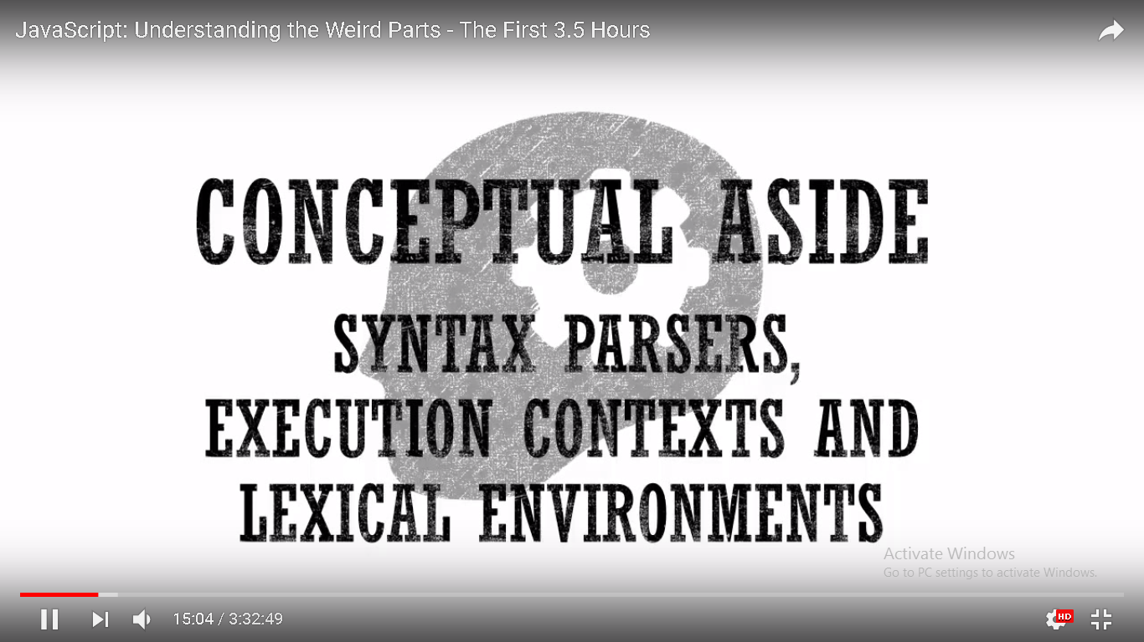

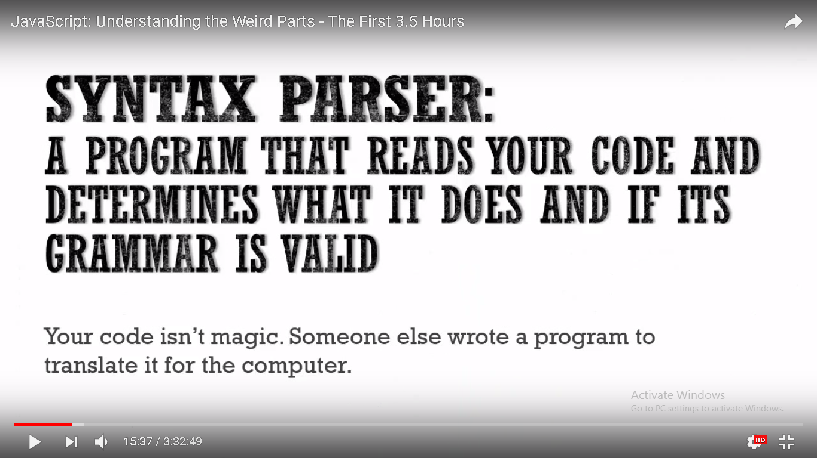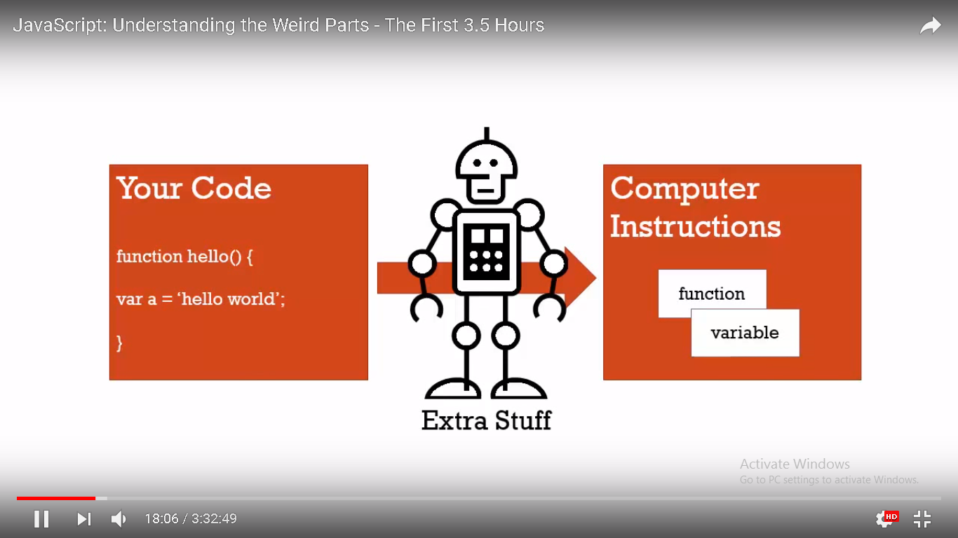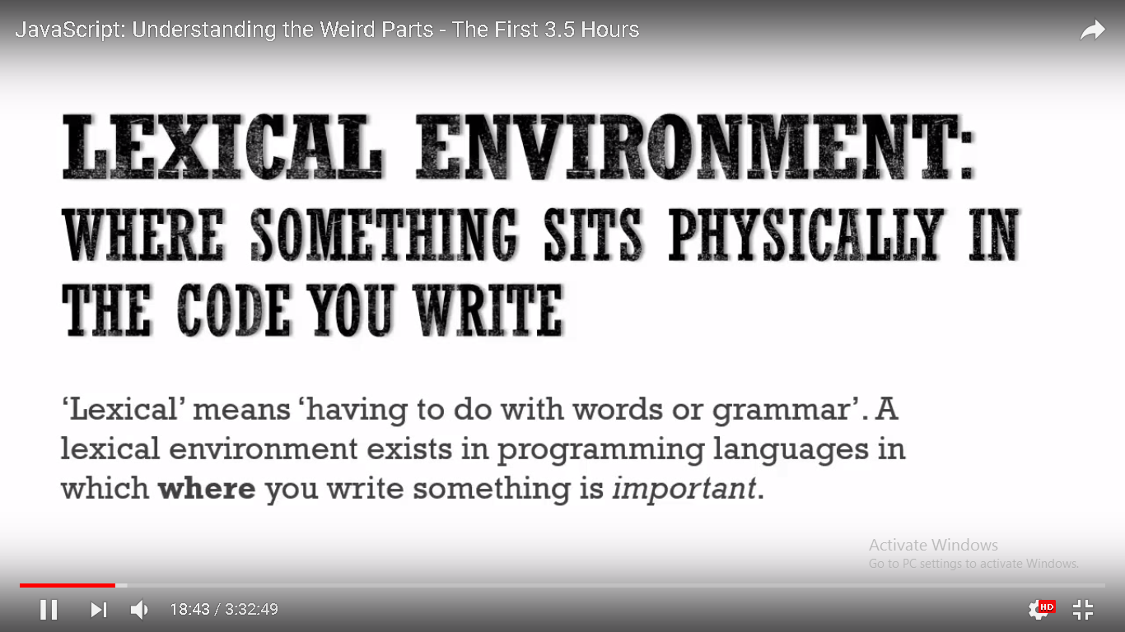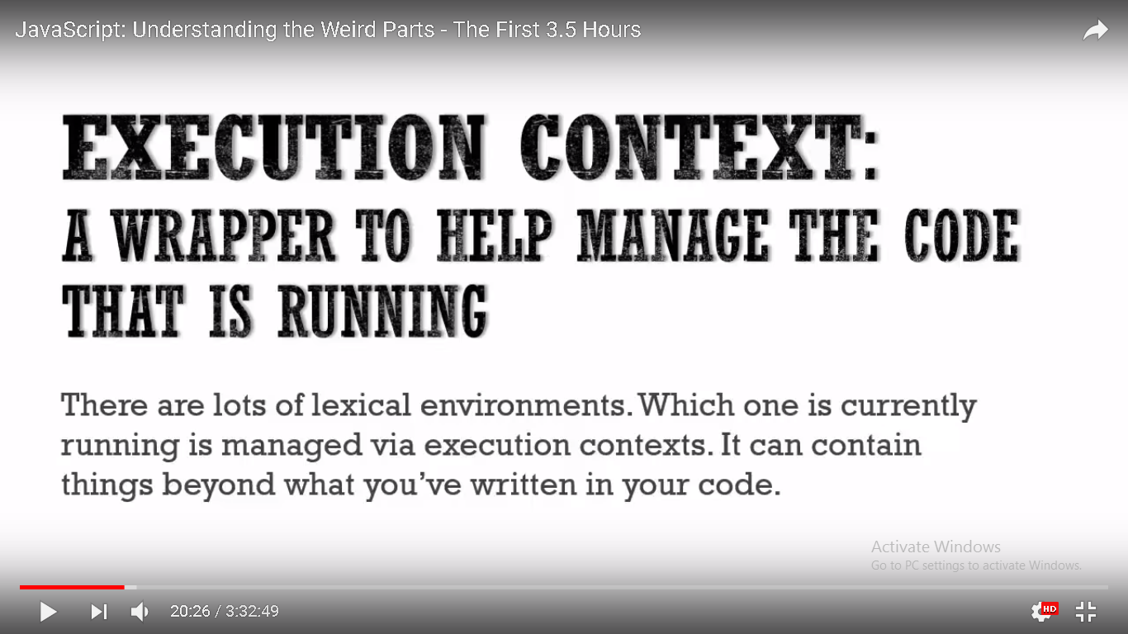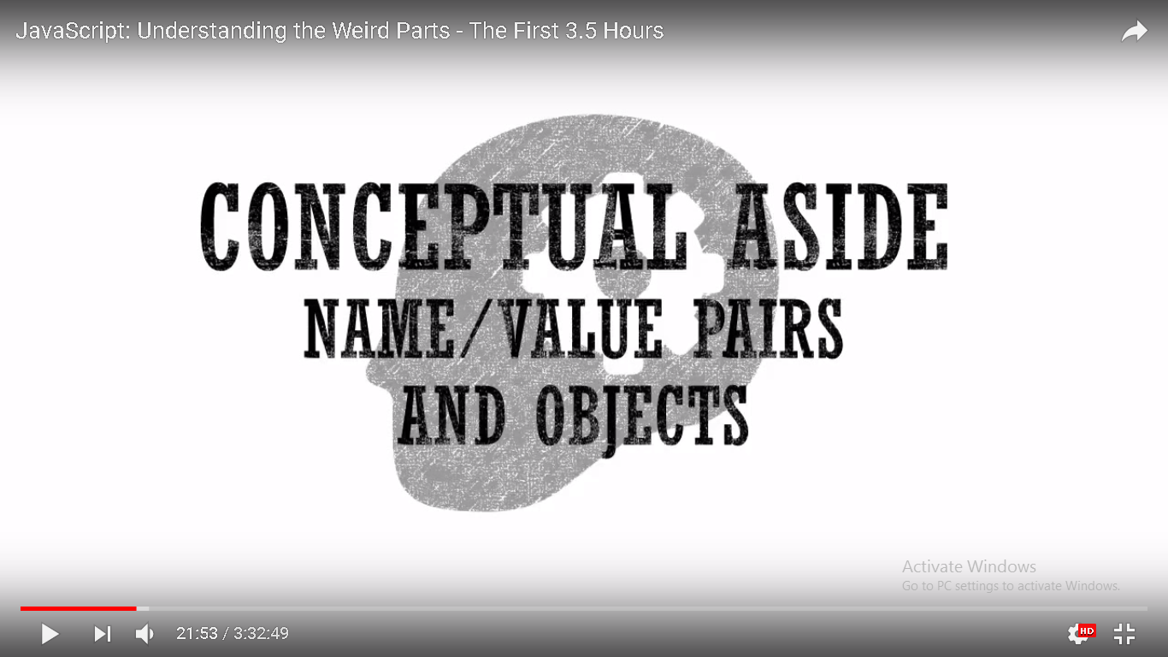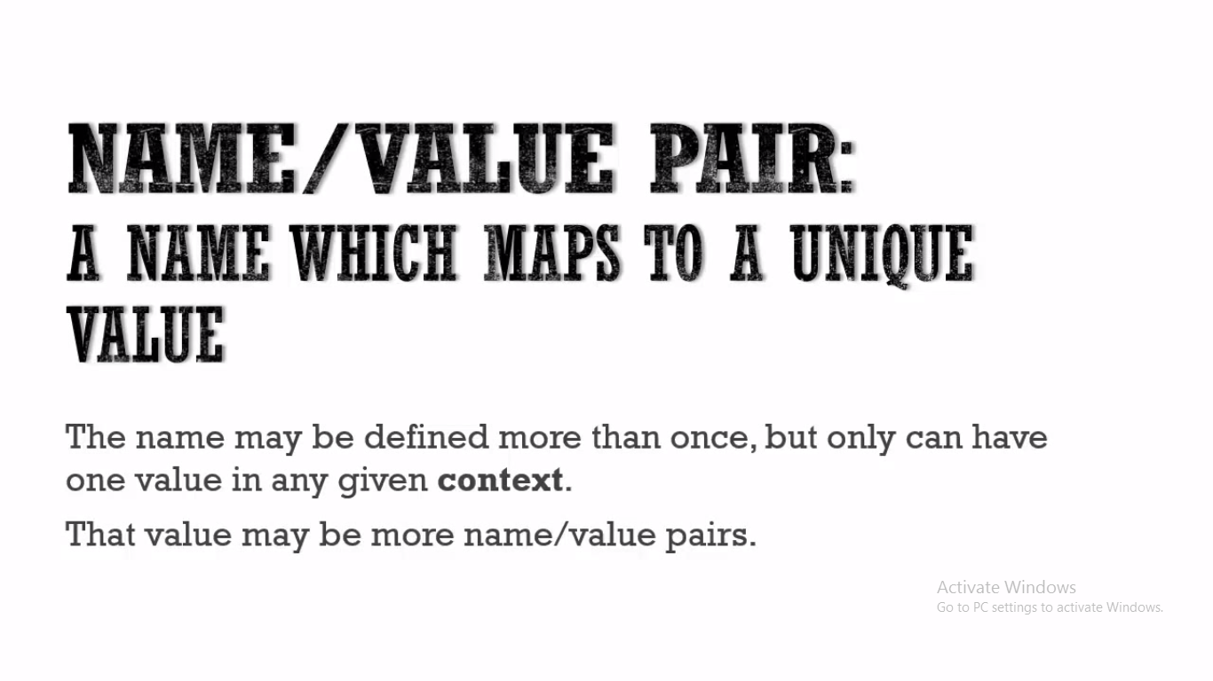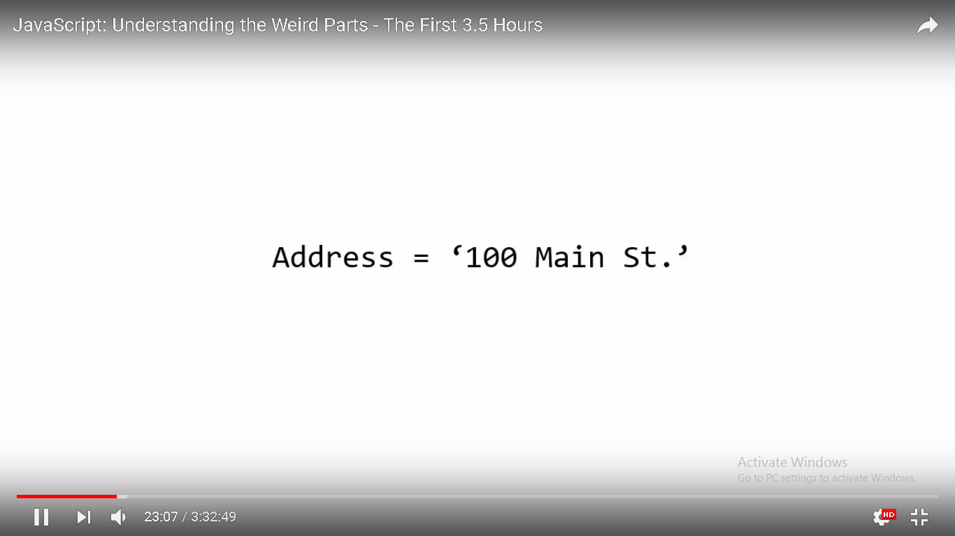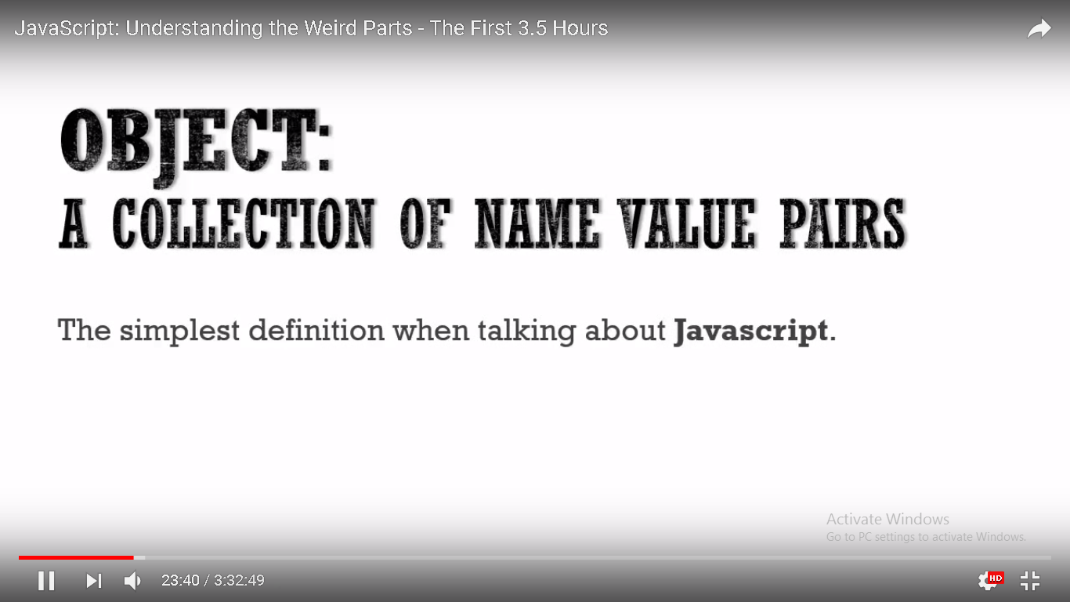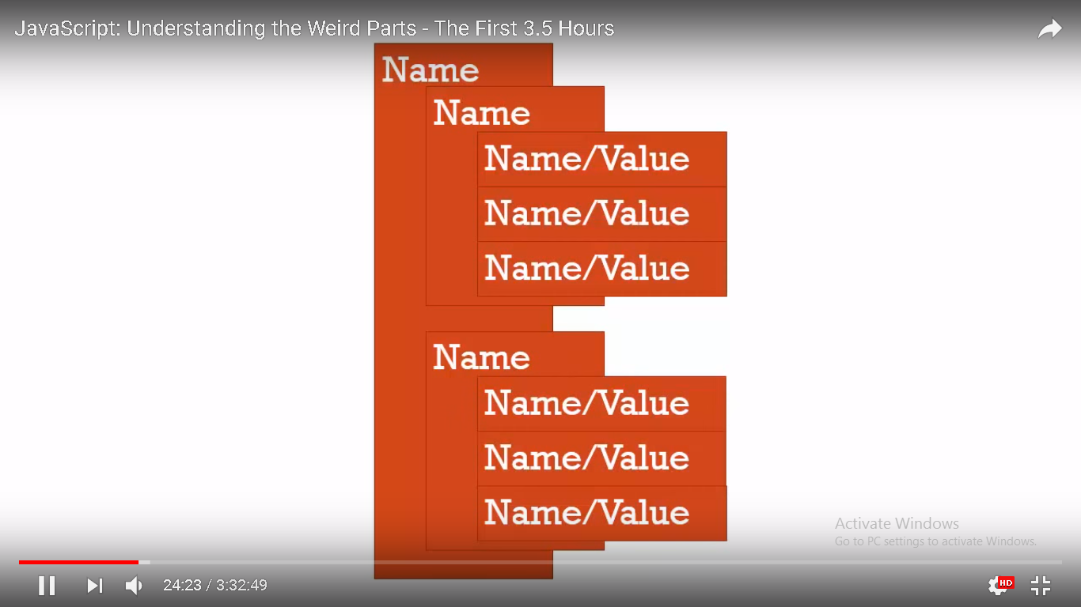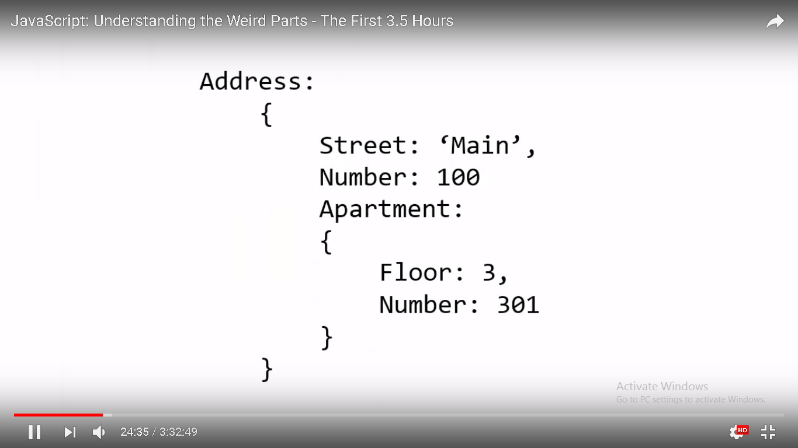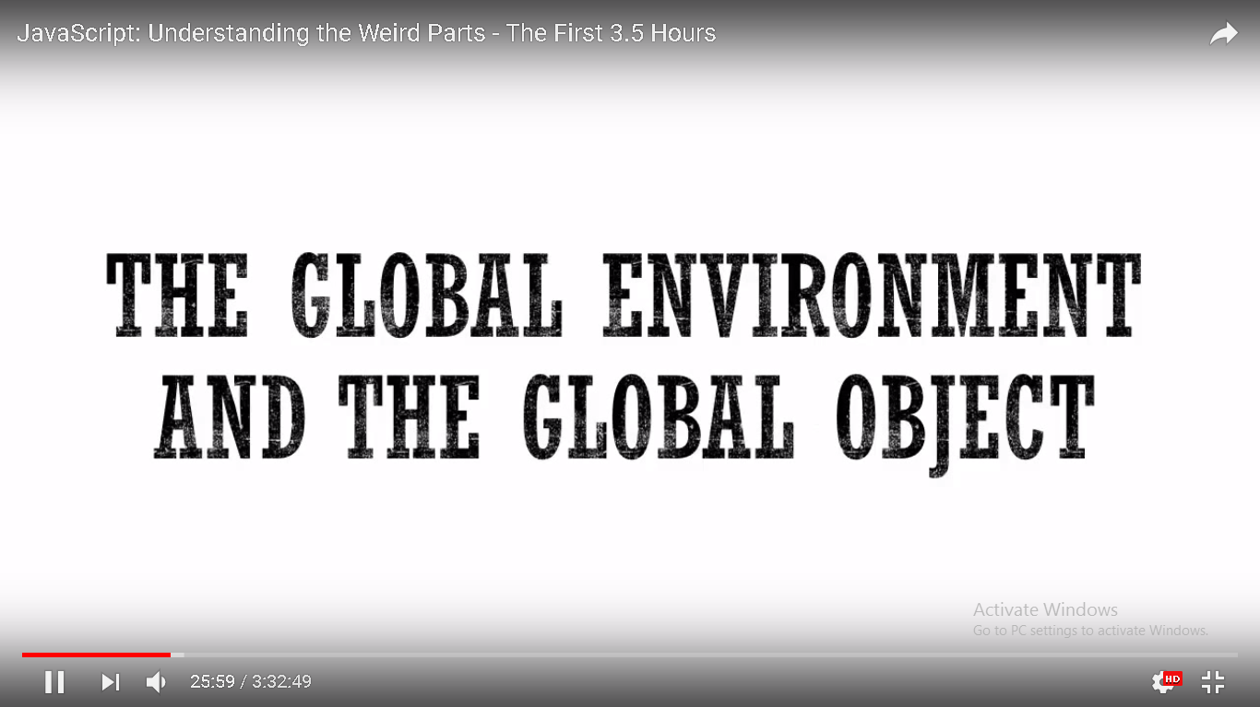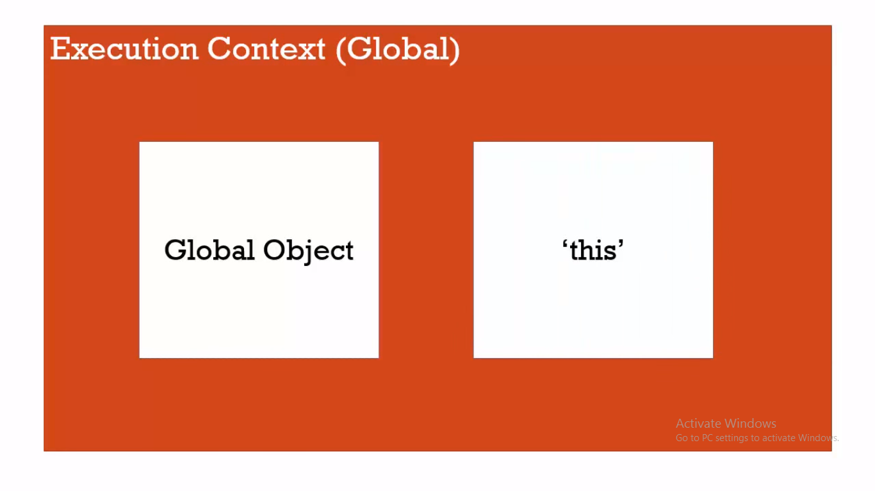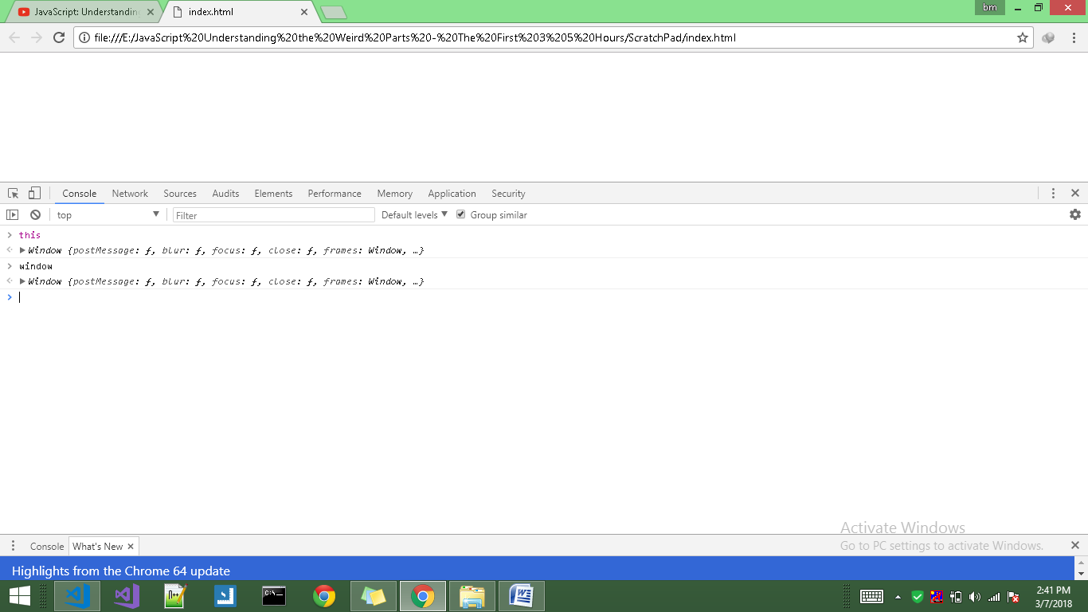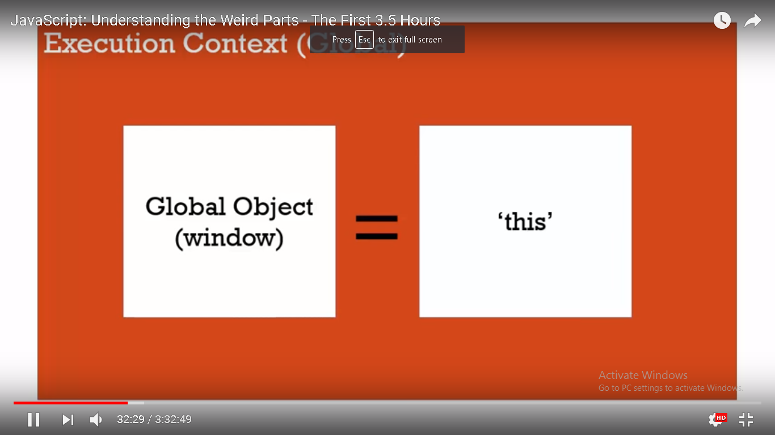whenever a code is run in javascript, it is run inside an 'execution context' meaning a wrapper that javascript engine (the program the other people wrote which is parsing, looking at, verifying and executing our code - that wraps up the code we have written in an execution context) creates.

when we look at our very first JavaScript program, we are going to be looking at an execution context being created and run and the base execution context (generally there are more than one execution context when a JavaScript program is run) which is the global execution context. the global(base) execution context creates a global object and a special variable for us called this.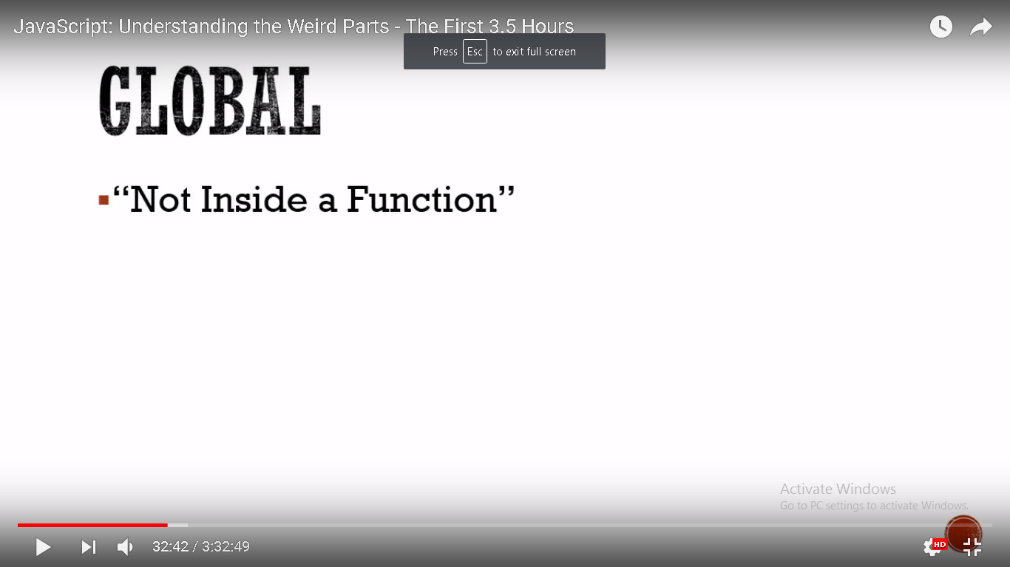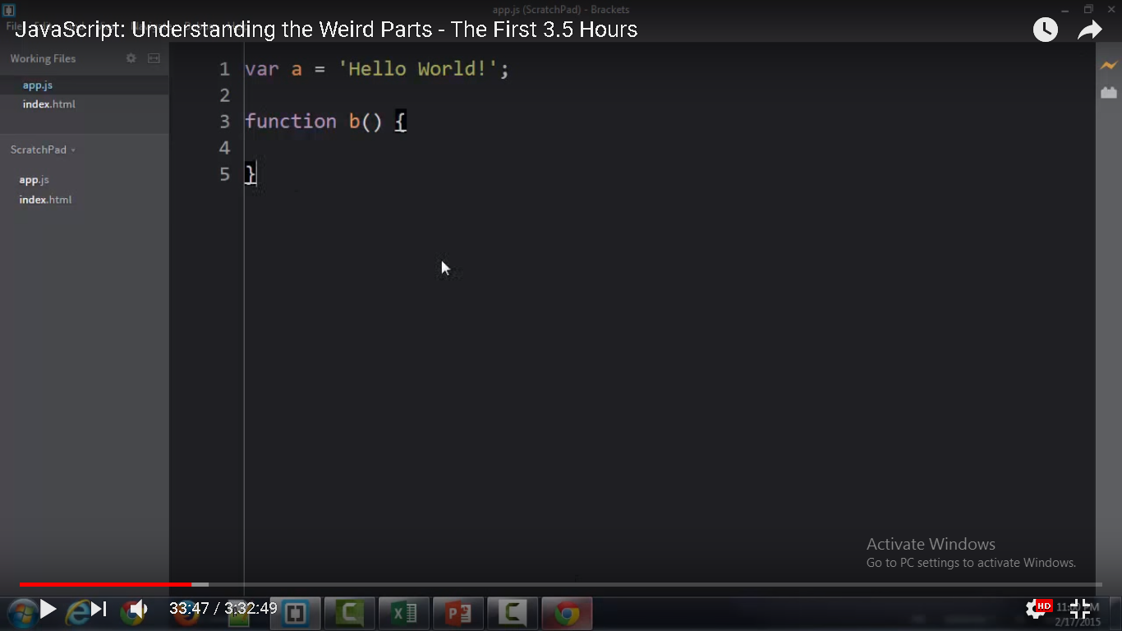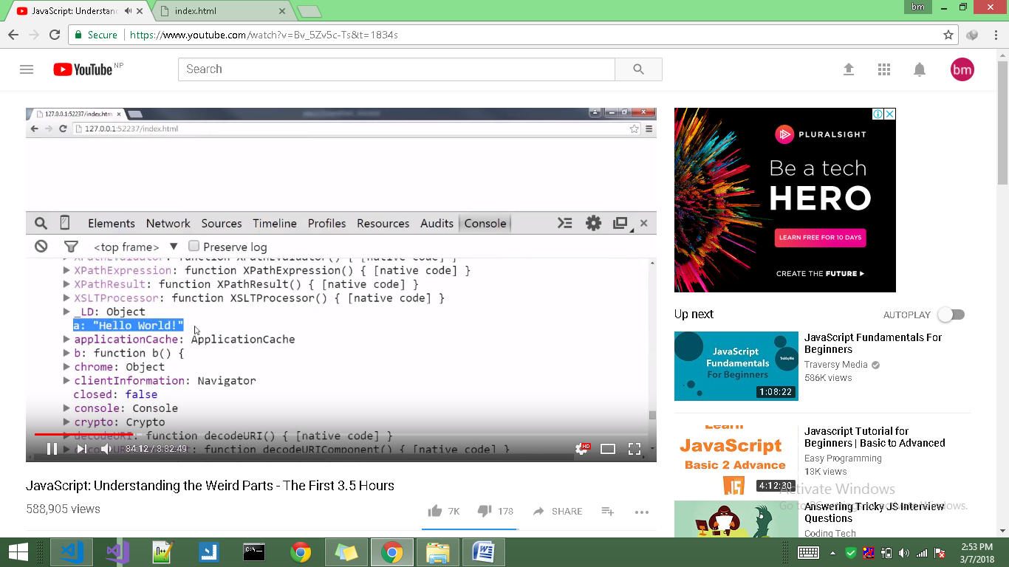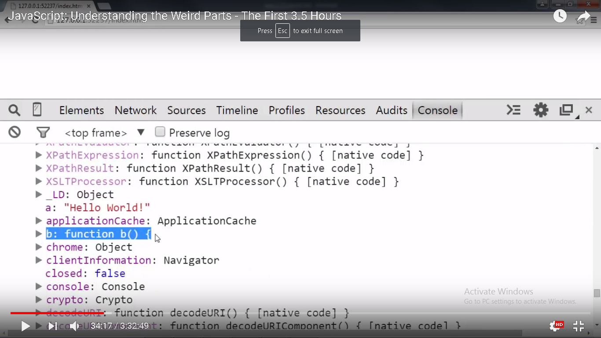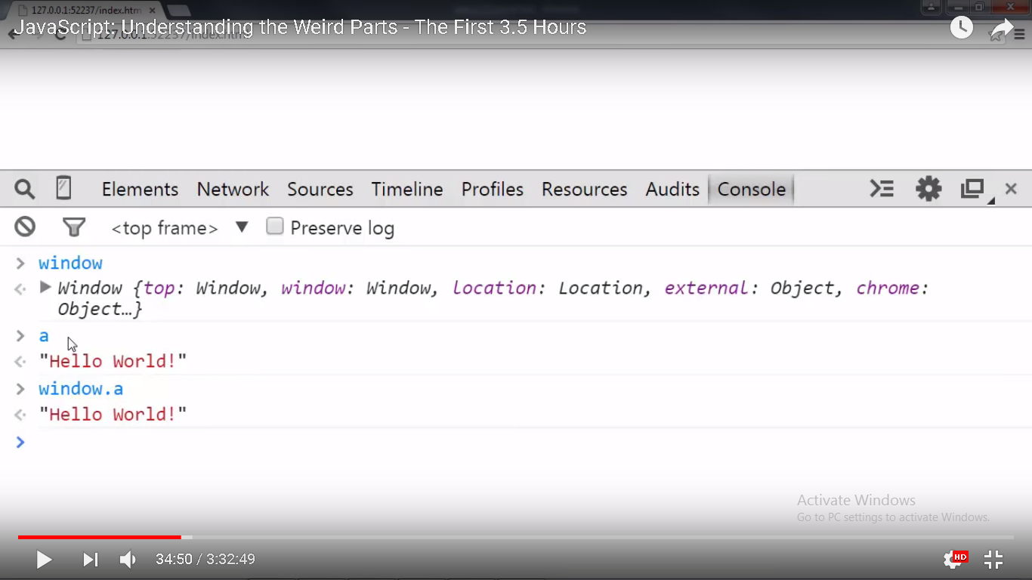

In Javascript, when we create functions and variables and we are not inside a function, those variables and functions get attached to the 'Global Object'.

when javascript code is executed, an 'Execution Context' is created. At the base level(when we are not inside a function) javascript engine creates 'Global Object' as a part of the 'Execution Context'.if we are running code inside a browser, that 'Global Object' is the 'window' object. we get a special variable called 'this'. in the case of browser, 'this' at that global level is the 'window' object.

when we are at code inside a function, 'outer environment ' means the code outside the function.

but when we are at the code at global level(meaning not inside any function), there is nothing outside ie there is no outer environment.

and finally the execution context is running our code.If we are creating variables and functions that are not inside a function then thats gonna sit on the global object.

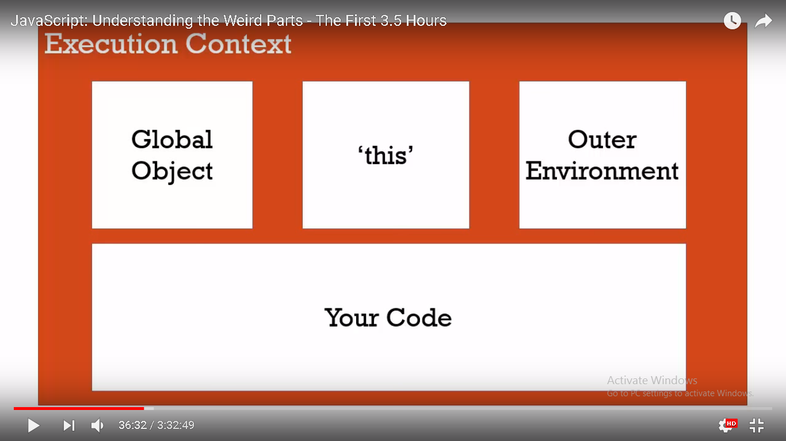

Now we have seen how javascript engine wraps up our executing code in an execution context. But there's an important aspect(one of those weirder parts of javascript) that we need to understand. And to understand it we just need to dig a bit more into what the javascript engine does to create an execution context.So this is the Execution Context :Creation and Hoisting.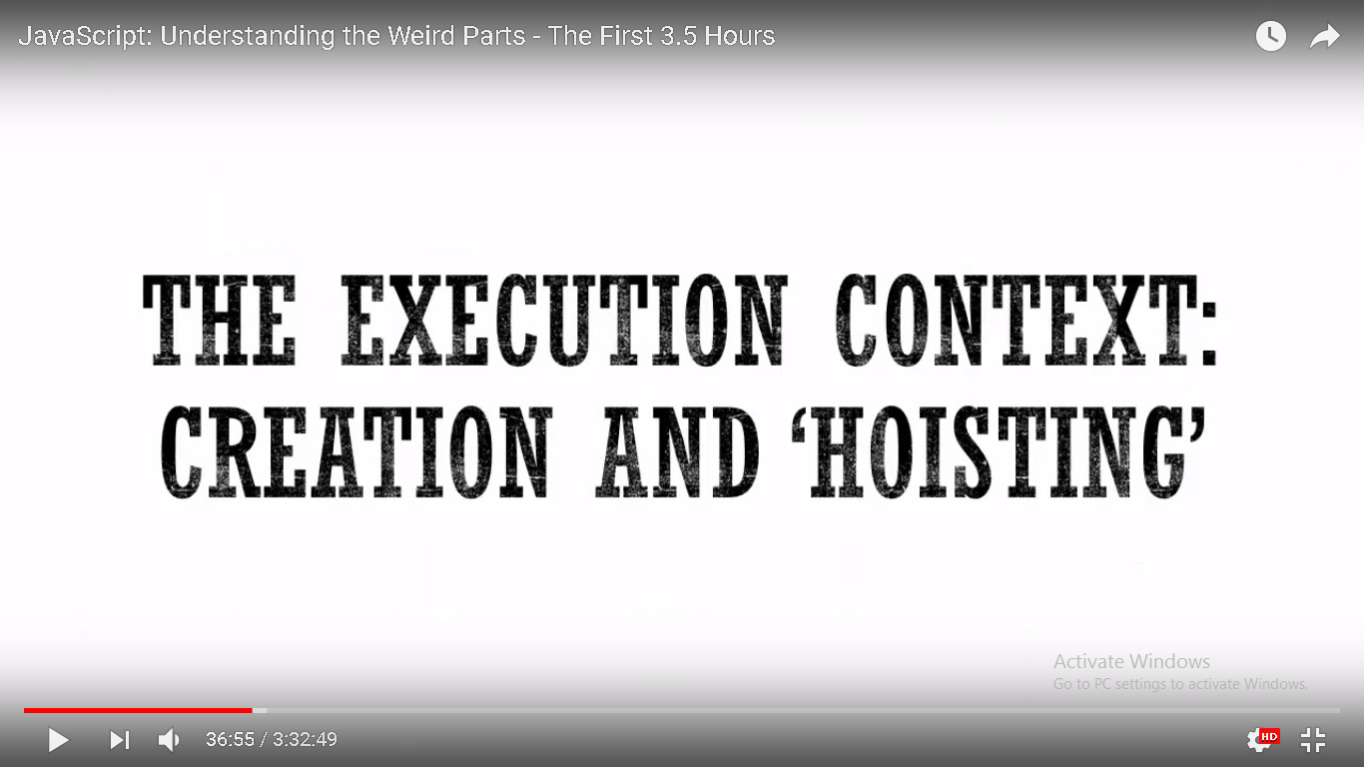

JavaScript engine creates the execution context in the following two stages:

1. Creation phase
2. Execution phase

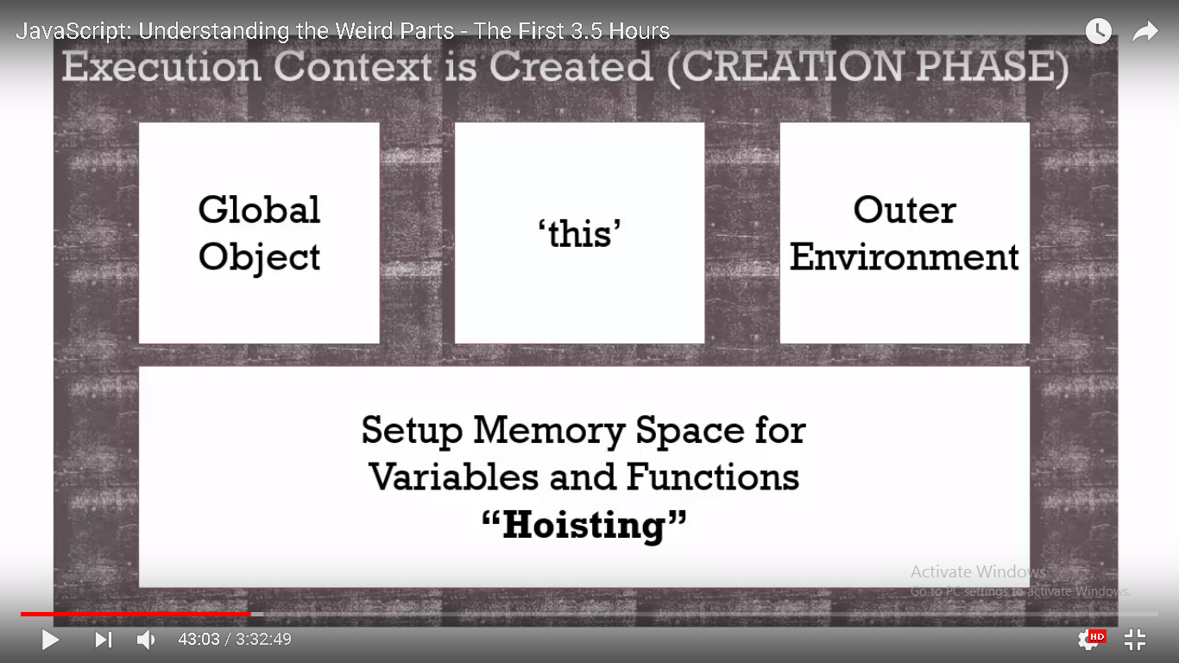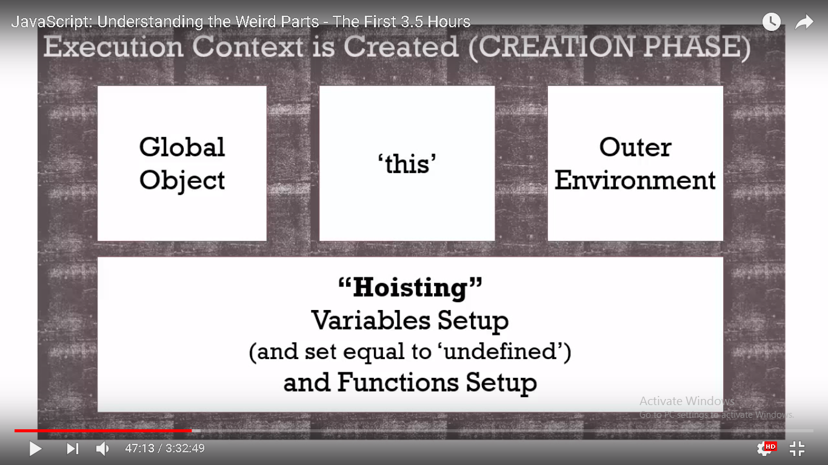

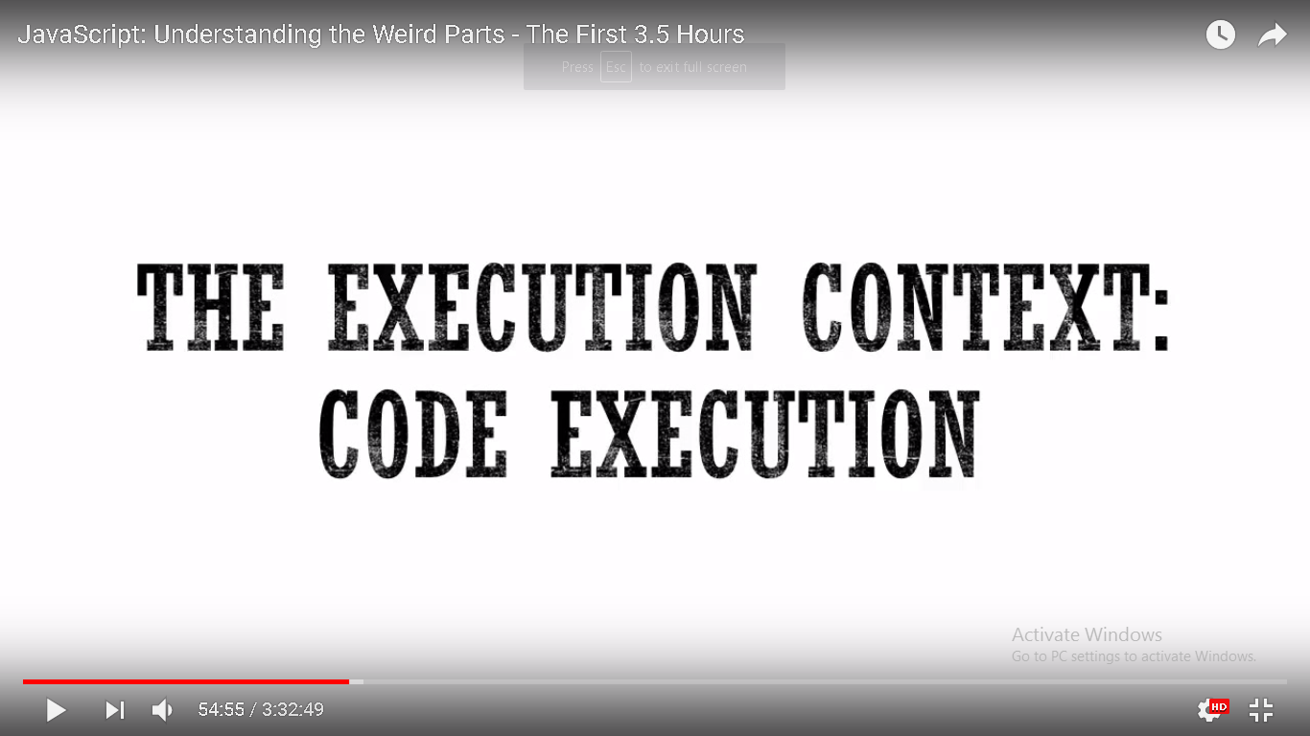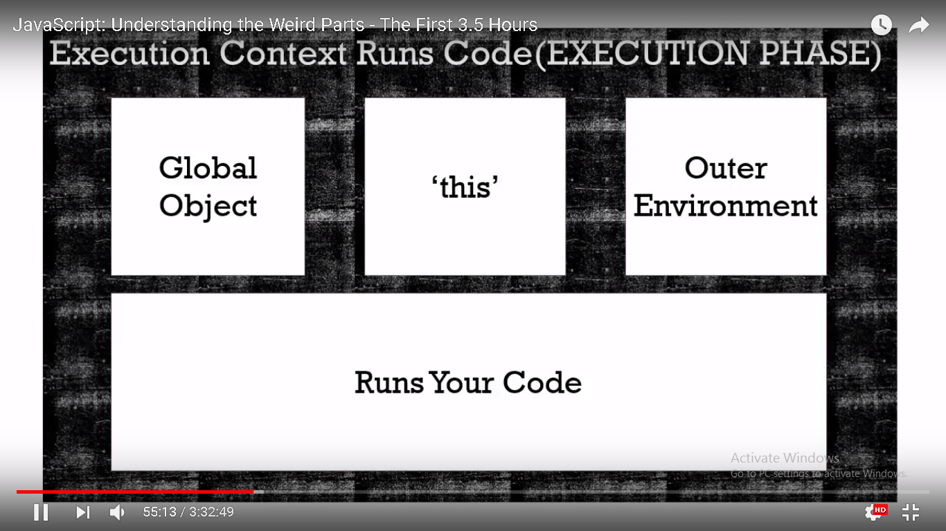

In execution Phase we already have those things setup we had before in creation phase. And now it runs our code line by line interpreting it, converting it, compiling it (into something that computer can understand), executing it on the computer

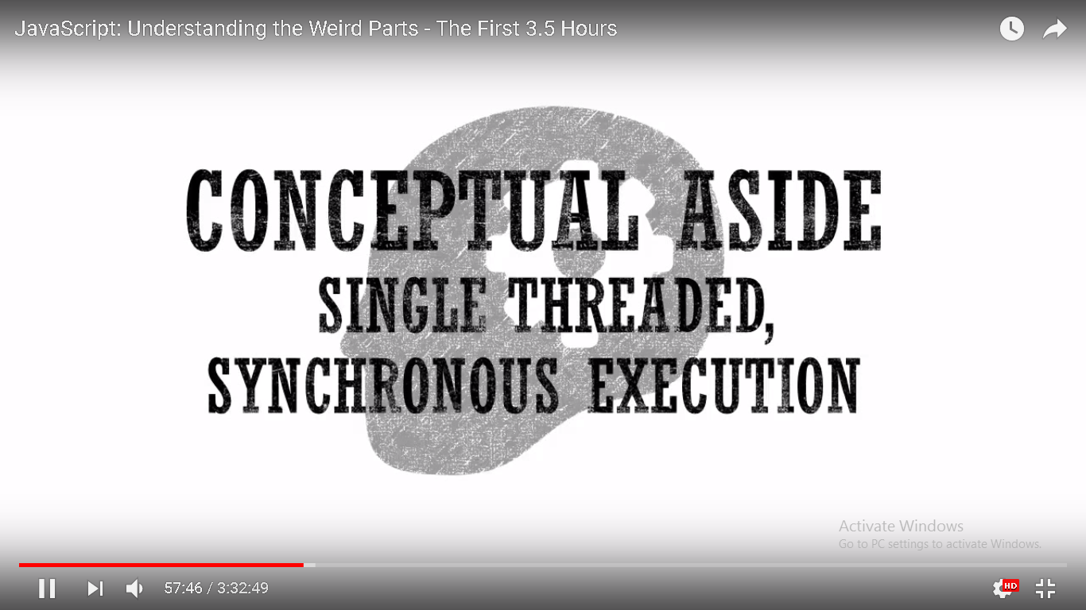 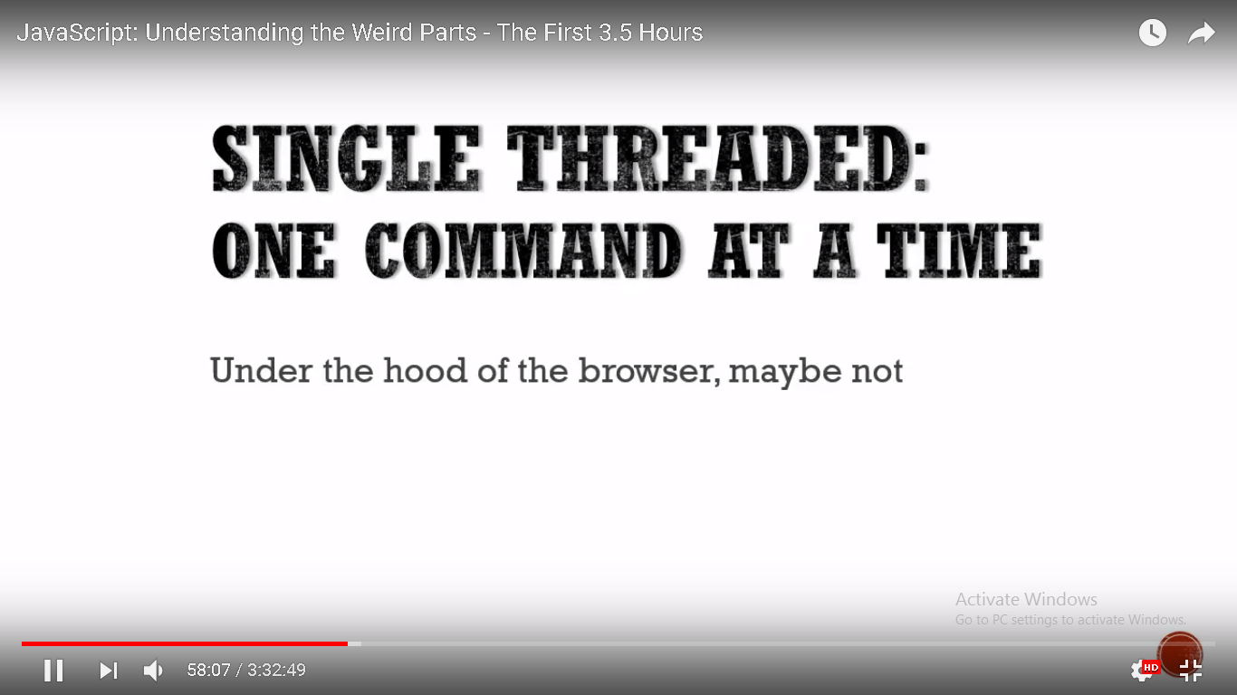

any program full of many commands within the code, single threaded execution means only doing one at a time. when we are dealing with browsers, understand that, JavaScript isn't the only thing happening in the browser. So when we say JavaScript is single threaded, it means that under the hood of the browser but from our perspective as programmers javascript behaves in a single threaded manner.

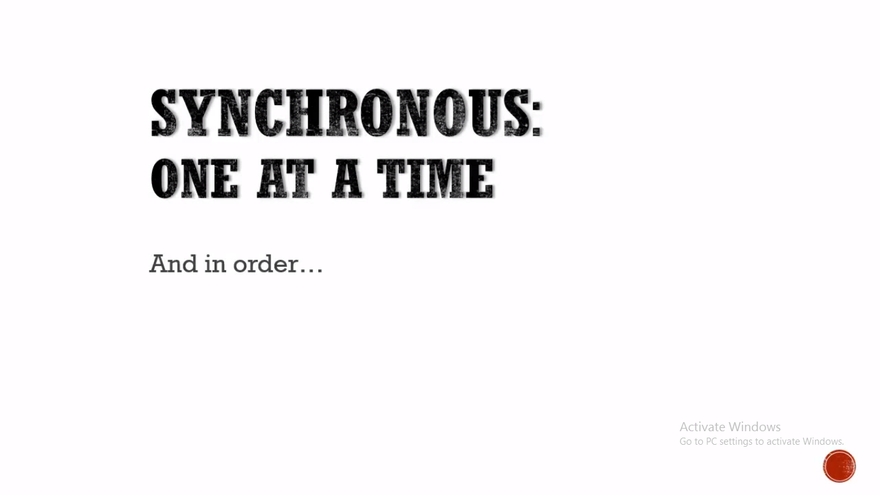

Synchronous, this is very similar to single threaded. synchronous meaning ,in the purpose of programming, one at a time in order that it appears.

Single threaded means that only one thing happens at a time.

Synchronous means that if you need to wait for something, then everything stops until the wait is over.

The most common example of synchronous vs asynchronous in JavaScript is making an HTTP request.

If you make a synchronous request, then you send out the HTTP request over the network and then everything stops. Mouse clicks are ignored. Timers that reach zero at put on hold. Nothing happens until the response gets back.

If you want an asynchronous request, then the JS engine carries on with other work. When the request comes back, and the JS engine isn't busy, then it is picked up and dealt with.

"In the end threading is about how many blocks of code (i.e. threads) we run on your computer's microprocessor simultaneously. If you have multiple 'cores' (like most modern Intel processors have) you can run multiple 'threads' simultaneously (i.e. each processor core is processing instructions at the same time).   
  
Javascript engines don't do this. Javascript doesn't necessarily get faster with more processor cores.   
  
On the other hand synchronous/asynchronous has to do with how a single thread is processed. Synchronous means 'wait for me to finish before doing something else'. Asynchronous means 'it's ok, keep going while I finish'. Javascript is synchronous and single-threaded. Only one thing is happening at a time within the engine, and only one set of instructions is being sent to your computer's microprocessor."

//comments on details about sync/async on this video start

[Bu Jin](https://www.youtube.com/channel/UC0NJ22L3VfwW9LIQ1f__mMA)[2 years ago (edited)](https://www.youtube.com/watch?v=Bv_5Zv5c-Ts&lc=Ugh62XNoyIELdXgCoAEC)

I do like the presentation style of this video, however some of the terminology in the video is incorrect. For instance synchronously does not mean one at a time, and asynchronously does not mean more than one at a time. Ironically in most of the English language synchronously means more than one thing happening at the same time (opposite of what's stated in the video), in computer science however the emphases on synchronously is given to that it's happening in sync, or in order, and asynchronously means it's happening out of sync, or out of order (depending on the context). Asynchronous is NOT a synonym for concurrent, we have concurrent to talk about concurrency. So it's not correct to say that JS is a synchronous language, because JS does allow for asynchronous programming models, that's what the event loop is all about. Now what you can say is that JS is a single threaded language, and only allows for one execution path at a time and not concurrent execution paths. Which is what I believe is being driven at.﻿

Show less

28

REPLY

[](https://www.youtube.com/channel/UCsFmLpSNJuFzpKqdEj5jeHw)

[Tony Alicea](https://www.youtube.com/channel/UCsFmLpSNJuFzpKqdEj5jeHw)[2 years ago](https://www.youtube.com/watch?v=Bv_5Zv5c-Ts&lc=Ugh62XNoyIELdXgCoAEC.85jX8Tnkq5U7-Hi6VzTd1Y)

+Bu Jin It is a common misconception to think JS has asynchronous ability. It doesn't. Look at the JS specification -- it mentions nothing about event loops. Those are constructs outside of the JS engine (built into the browser, or in NodeJS the built-in libuv library, for example). JS engines do NOT implement asynchronous models. JS engines are always embedded in other software (browser/NodeJS) that handle that, so it can make it feel like its part of the engine. Thanks!﻿

Show less

9

REPLY

[](https://www.youtube.com/channel/UC0NJ22L3VfwW9LIQ1f__mMA)

[Bu Jin](https://www.youtube.com/channel/UC0NJ22L3VfwW9LIQ1f__mMA)[2 years ago](https://www.youtube.com/watch?v=Bv_5Zv5c-Ts&lc=Ugh62XNoyIELdXgCoAEC.85jX8Tnkq5U7-I6kLPMiJz)

+Tony Alicea I appreciate you taking the time to respond to my comment, but I feel you focused in on one (irrelevant) item to the exclusion of my point. Your terminology is inaccurate whether or not the JS spec defines an event loop (which all JS environment implementations have, whether it's defined or not, you even talk about it in your video as though it's a given). Though looking at the spec ([http://www.ecma-international.org/ecma-262/6.0/](https://www.youtube.com/redirect?event=comments&redir_token=1ro1gvKXGeJXkuK4t1sMMP7daf58MTUyMDUxNDQzM0AxNTIwNDI4MDMz&q=http%3A%2F%2Fwww.ecma-international.org%2Fecma-262%2F6.0%2F)) you'll notice it says nothing about JS being a "synchronous" language either (since you bring up what the spec does and doesn't mention), though asynchronous constructs (promises) and events are specifically mentioned. My point is that you are incorrectly defining synchronous as only handling one thing at a time, and asynchronous as handling more than one thing at a time. That is not the definition of those terms, computational concurrency is a separate matter from synchronicity.   It is true that JS is not a concurrent language. JS lacks the syntax and grammar to even describe threads, let alone thread management, so it's not a concurrent language. It's worth noting at this point that concurrent languages rely on mechanisms outside of the language to spawn threads. In C++ you have to request a thread from the operating system, or you have to ask the system to fork a process, as those are OS resources and the OS has to provide them. It's simply up to the language to be expressive enough to describe the interaction. But is JS an asynchronous language? The"key" characteristic of an asynchronous program is that the order of execution is indeterminate by the programmer, that would be a rather academic definition, a more practical description would be, that it allows for a non-blocking approach to things like IO as well as an event model (notice that the academic definition holds in this practical description, and can be implemented in a single thread).  Whether or not the event loop itself is officially specified by the ES committee, whether or not the the event loop exist outside of the JS engine proper, the language is powerful enough and expressive enough to facilitate its usage, or asynchronous programs simply wouldn't be possible (and I think we have all seen a SPA). I certainly don't see a distinction between JS making use of external resources to facilitate asynchronicity, any more than C++ making use of the OS to facilitate concurrency, the question is can the language handle it. Now, even if asynchronous programs couldn't be written in JS (which they can and are), it wouldn't change the fact that you are inaccurately describing synchronous/asynchronous to mean concurrent execution. Consequently your definition precludes the possibility of a single threaded asynchronous environment altogether, however, there are many examples of such environments beyond JS.﻿

Show less

5

REPLY

[](https://www.youtube.com/channel/UCsFmLpSNJuFzpKqdEj5jeHw)

[Tony Alicea](https://www.youtube.com/channel/UCsFmLpSNJuFzpKqdEj5jeHw)[2 years ago](https://www.youtube.com/watch?v=Bv_5Zv5c-Ts&lc=Ugh62XNoyIELdXgCoAEC.85jX8Tnkq5U7-Klv49XtQE)

+Bu Jin I see what you're saying -- I think sync/async, concurrency, threading are used in different ways in different contexts. However when we're talking about sync/async we're really talking about blocking and non-blocking. A synchronous process blocks, an asynchronous process does not, as you say. JS blocks. It completes its execution before allowing further code to execute. Event loops like libuv just execute JS functions -- however JS blocks that execution if the event occurs while other code is running (i.e. if you click a button and JS is running other code, that code will finish before the browser's request to process the click event listener is run). Non-blocking JS doesn't exist really -- it is only made possible by something external to the JS engine (and the fact that JS has first-class functions, which provide a useful method to manage event listeners). SPAs are made possible by the browser, not JS. JS blocks. In the sense of blocking/non-blocking JS is not asynchronous. In the simplest terms, I think its useful to say blocking means 'one thing at a time' and non-blocking is 'more than one thing at a time'.﻿

Show less

5

REPLY

[](https://www.youtube.com/channel/UC0NJ22L3VfwW9LIQ1f__mMA)

[Bu Jin](https://www.youtube.com/channel/UC0NJ22L3VfwW9LIQ1f__mMA)[2 years ago (edited)](https://www.youtube.com/watch?v=Bv_5Zv5c-Ts&lc=Ugh62XNoyIELdXgCoAEC.85jX8Tnkq5U7-KqbWmn9fz)

+Tony Alicea Thank you again for your thoughtful response. Since you seemed to have homed in on blocking it appears you are still confusing concurrency with synchronicity.   Yes, anything that consumes CPU resources blocks. Doesn't matter what language you are talking about, it can be Java, C++, C#, take your pick. All languages get compiled down to machine op code, get physically ran on an ALU, and while that is happening, nothing else is, period. Now there are ways to fake concurrency without actually having concurrency (because true concurrency requires multiple execution cores), and it's call time slicing. The OS breaks up tasks in to executional slices and then load balances them in order to give other things a turn and to allow for interrupts. That's how Unix manages to be so incredibly responsive even on a single core system. But getting back to asynchronicity, again, the "key" characteristic of an asynchronous program is that you can't predetermine the execution path. Let's say you are writing a piece of software that is CLI based with a simple menu structure, you know, press 1 for this option, press 2 for that option, etc. Everything is deterministic. Everything is just a matter of branching and looping, every function can simply just return to the point of call and the app will continue on. That is a "synchronous" program, everything is in sync, every function return returns right where it left off, thus, in sync. Once you start talking about events, where you can have an unknown execution entry point, as soon as the code starts "requiring" callbacks (because it can't just return to the point of relevance, because the call has been disassociated), it's now an asynchronous program (because it's no longer in sync), because you can no longer define its structure synchronously. The JavaScript language, is asynchronous (allowing asynchronous interactions, example: func(callback)), regardless of whether or not the JS engine allows for concurrency (I hope you recognize the difference between a "language" and an interpreter). If JS didn't provide for callbacks (or something similar), if all you had was simple returns to the point of call, then you would be right, because there would be no way to handle the complexity of asynchronous interactions, however that's not the case. ...and more to the point, regardless of where things come down with JS, asynchronous does not mean multiple execution, it's means flow disassociated execution. And one other thing, if JS was a synchronous language, not allowing for arbitrary execution entry points, then SPAs, as well as a host of other things, would not be possible. The only reason you can write this sort of software in the browser is because JS does allow for callbacks. Otherwise, we'd be stuck with Flash or Java, or trying to bring some other language to the browser, because JS wouldn't be powerful enough to write meaningful software. BTW: I do agree, sync/async gets used in different ways in different contexts. (Can't think of too many contexts for concurrent and multithreaded, because they are far too topic specific.) However, you can't completely misappropriate a term and simply say it's a new context.   Synchronous, adjective: 1. Happening, existing, or arising at precisely the same time 2. Recurring or operating at exactly the same periods 3. Involving or indicating synchronism -taken from Merrian-Webster Now in Computer Science we camp on that third definition most of the time. Synchronous can mean that something is in the same state. Such as having two file systems in sync, or two profiles, etc. It can have to do with scheduling, such as in serial interfaces, when things must be sent or received on the rise or fall of the clock. Could be in video where you want your video and audio stream to be in sync. It could be talking about transactions, where they are order specific, and thus sync is talking about the order being correct (this by the way is the same usage as in sync/async programming, where it's referring to execution ordering).   You will notice that each and every one of these CS uses have in common the associative relationship of at least two things and time. If you simply decompose the word you see the "syn" (literally a Greek morpheme meaning "together") like in synonym, where you have two similar words (words that are together in meaning), the "chronous" (with the Greek morpheme root "chron" meaning time) like chronology or chronicle etc, and thus the literal meaning for synchronous is "being together in time", which together implies plurality as you can't have a singular togetherness (it would be like saying I'm together with myself, it's nonsensical). Therefore, it is very clear that synchronous has to do with multiple things being correctly coordinated in time, thus happening at the same time, thus the definition of synchronous programming CANNOT refer to something happening one at a time, and more over the negated form CANNOT be multiple things happening at the same time, as that would be the exact opposite of the base lexical meaning.  In fact asynchronous literally means "not together in time", which is the exact meaning of "one at a time". The misconception that synchronous programming means one at a time, comes from the fact that in a synchronized program, where everything happens in order, in sync, that one thing finishes and flows into the next, it is not possible to allow for arbitrary execution entry (which is a requirement for most concurrent designs). Async means you are breaking with the natural synchronized flow of the processing order, which is required for your typical concurrent effort, which has lead to the misunderstanding that async means more than one thing happening at a time (as async is a basic requirement for the most used forms of concurrency, though it itself is not concurrency).   Now you like to say "Don't imitate, understand", but your definitions seem completely arbitrary and predicated on a colloquialized false association (like how people falsely inverse the meaning of peruse to mean browse, and scan to mean skim), which is not a valid position for such a technical subject. I challenge you to defend synchronous as meaning one at a time and asynchronous as meaning more than one at a time (these definitions are antithetical to the inherent meaning of these words), I would like you to provide a morphological proof of that usage.﻿

Read more

9

REPLY

[](https://www.youtube.com/user/NeverUsePaypaI)

[Tis'ur"Master'"](https://www.youtube.com/user/NeverUsePaypaI)[2 years ago](https://www.youtube.com/watch?v=Bv_5Zv5c-Ts&lc=Ugh62XNoyIELdXgCoAEC.85jX8Tnkq5U7-KtDlT1Bju)

+Bu Jin Agree. However, it's a very good video and how it's presented.﻿

5

REPLY

[](https://www.youtube.com/user/mbdesign07)

[B K](https://www.youtube.com/user/mbdesign07)[2 years ago](https://www.youtube.com/watch?v=Bv_5Zv5c-Ts&lc=Ugh62XNoyIELdXgCoAEC.85jX8Tnkq5U7-nf31sNSWU)

+Bu Jin You must a expert in javascript. have any videos? This is one of the best js videos I've ever seen.﻿

13

REPLY

[](https://www.youtube.com/user/animowany111)

[animowany111](https://www.youtube.com/user/animowany111)[2 years ago](https://www.youtube.com/watch?v=Bv_5Zv5c-Ts&lc=Ugh62XNoyIELdXgCoAEC.85jX8Tnkq5U87aOT3M13se)

+Bu Jin +Tony Alicea It's not true that Javascript doesn't have any sort of threading support. Javascript supports web workers and service workers, which have stripped down versions of the global object and communicate with the main window (or thread) via postMessage(), (and service workers can capture HTTP requests and modify them as well). It's not the easiest nor most convenient to use, but it's powerful.﻿

Show less

1

REPLY

[](https://www.youtube.com/channel/UCsFmLpSNJuFzpKqdEj5jeHw)

[Tony Alicea](https://www.youtube.com/channel/UCsFmLpSNJuFzpKqdEj5jeHw)[2 years ago](https://www.youtube.com/watch?v=Bv_5Zv5c-Ts&lc=Ugh62XNoyIELdXgCoAEC.85jX8Tnkq5U87aPXf-Kwzz)

+animowany111 Web workers are not part of JavaScript. Check the JS specification: [http://www.ecma-international.org/ecma-262/6.0/index.html](https://www.youtube.com/redirect?event=comments&redir_token=1ro1gvKXGeJXkuK4t1sMMP7daf58MTUyMDUxNDQzM0AxNTIwNDI4MDMz&q=http%3A%2F%2Fwww.ecma-international.org%2Fecma-262%2F6.0%2Findex.html) they aren't found anywhere. Web workers are implemented by the browser.﻿

2

REPLY

[](https://www.youtube.com/user/animowany111)

[animowany111](https://www.youtube.com/user/animowany111)[2 years ago](https://www.youtube.com/watch?v=Bv_5Zv5c-Ts&lc=Ugh62XNoyIELdXgCoAEC.85jX8Tnkq5U87aRwHhVAJQ)

+Tony Alicea I stand corrected, it's not part of the EcmaScript standard, it's part of the HTML5 spec. [https://html.spec.whatwg.org/multipage/workers.html](https://www.youtube.com/redirect?event=comments&redir_token=1ro1gvKXGeJXkuK4t1sMMP7daf58MTUyMDUxNDQzM0AxNTIwNDI4MDMz&q=https%3A%2F%2Fhtml.spec.whatwg.org%2Fmultipage%2Fworkers.html) My argument is void, but recent browser implementations will support workers / threading, which most Javascript targets. Thanks for pointing this out.﻿

Show less

4

REPLY

[](https://www.youtube.com/channel/UCjyonbMs3zYH5R1DgvxMBzw)

[kenneth renninger](https://www.youtube.com/channel/UCjyonbMs3zYH5R1DgvxMBzw)[2 years ago](https://www.youtube.com/watch?v=Bv_5Zv5c-Ts&lc=Ugh62XNoyIELdXgCoAEC.85jX8Tnkq5U88iN_Qmynn1)

not only was the video informative but this very discussion helped out with certain aspects of the concept of js...great job to the both of you on the mannerism in wich the discussion was carried out.﻿

11

REPLY

[](https://www.youtube.com/channel/UCNNxmxJeexg-zIOc8L0q_cg)

[Yasaa Moin](https://www.youtube.com/channel/UCNNxmxJeexg-zIOc8L0q_cg)[5 months ago](https://www.youtube.com/watch?v=Bv_5Zv5c-Ts&lc=Ugh62XNoyIELdXgCoAEC.85jX8Tnkq5U8XMvKs0XzNf)

Bu Jin this discussion was really helpful in grasping concepts better.I seriously would never have considered JS and browser to be different ,really.I thought the browser does exactly what js asks for,and no extra functionality.These engines,like Chrome V8 have really come pretty far﻿

//comments on details about sync/async on this video end

conclusion=> Javascript is single threaded and synchronous in its behavior.

All this time , we have been talking about the global execution context and how its created and executed. But we also mentioned functions are special in regards to this. Here we will talk about function invocation and execution stack. And we will be going to introduce this concept that will be fundamental in understanding some very important advanced concepts in javascript.

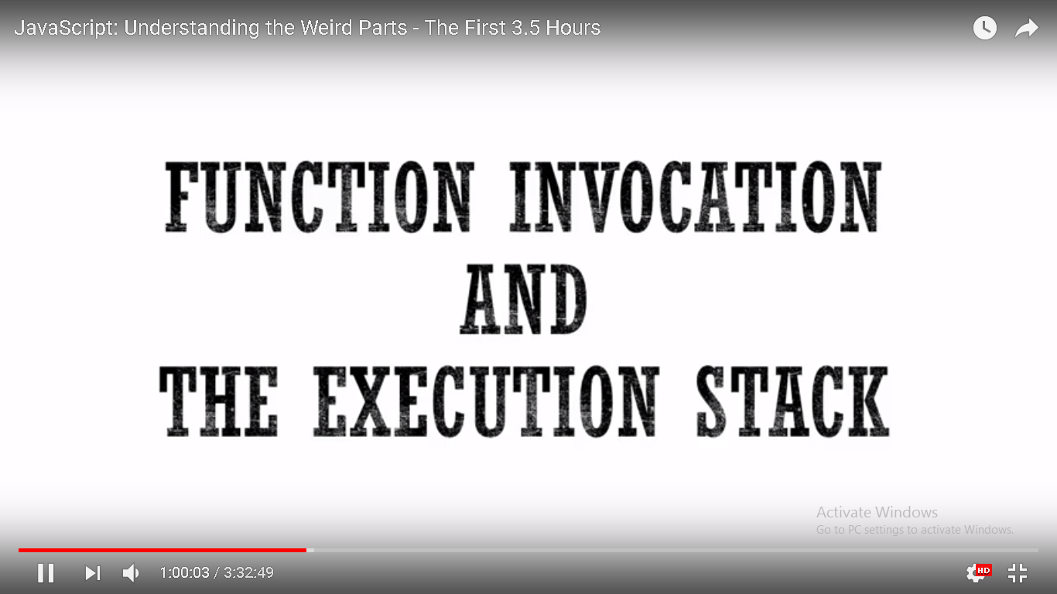

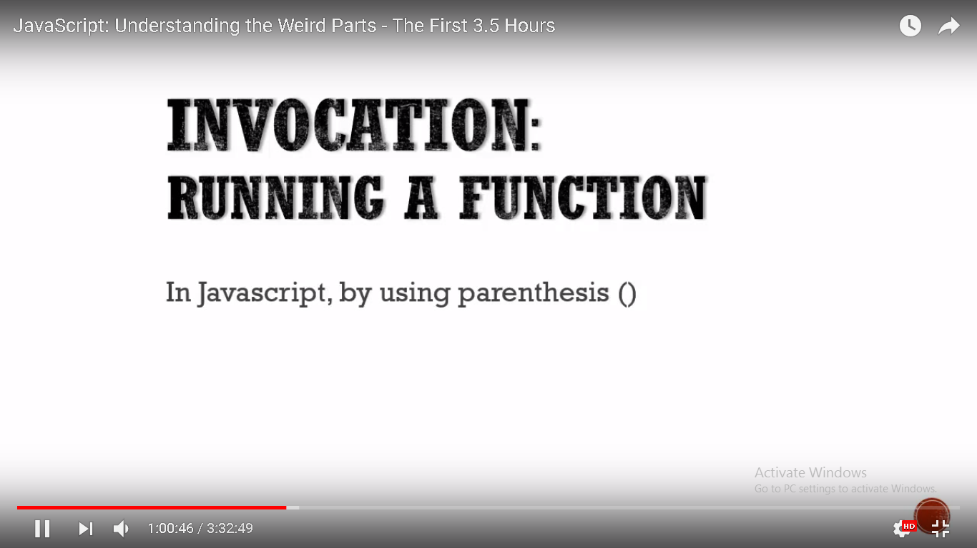

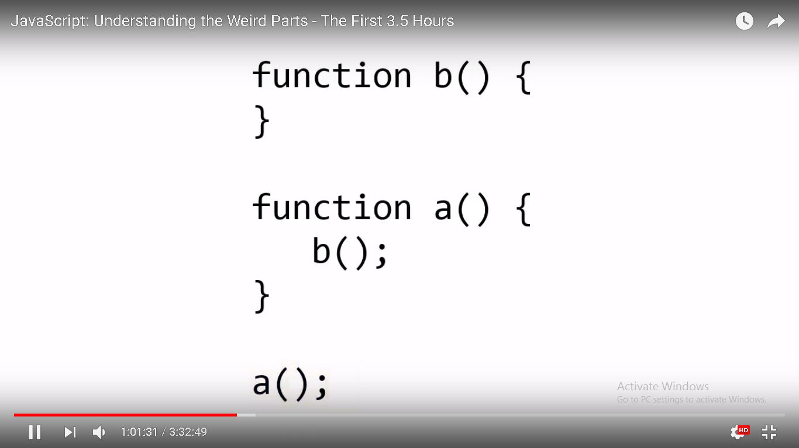

what happen when we invoke a function in javascript?

let's look at the simple example.

its a simple example but it helps us understand what's happening under the hood.

here comes the fundamental very important concept. Lets step through what we know is going to happen first. if I put this code in a javascript file and ran it. first of all what's going to be created? answer is Global execution context.

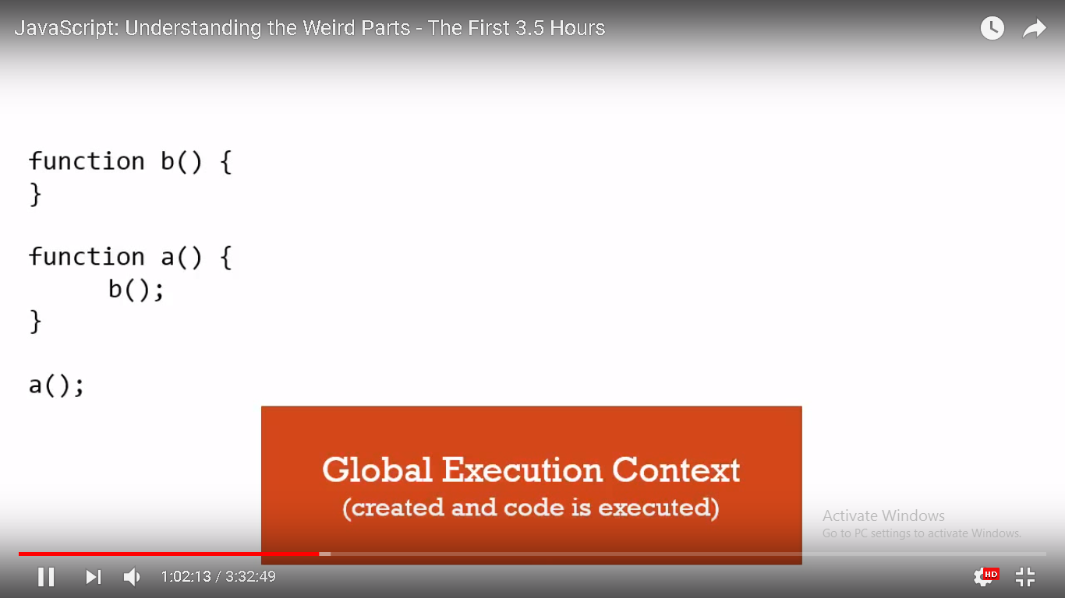

The parser parse the code, and then compiler(the program that interprets our code) will start up and say well i need to create a global execution context which will create a variable 'this', create a global object(if we are in a browser it will create a window object) then it will attach these function to that global object .in other words it will set up memory for them in the Creation Phase(1st phase) of the execution context. so the functions b and a will be in memory. And then code will be executed line by line. now it won't execute anything in those functions because they haven't been invoked.

when it hits a(); at the bottom, it says ah! i am supposed to invoke that function a(). Here's the thing that actually happens. A new Execution Context is created and placed on what's called 'The Execution Stack'. And stack is just what it sounds like- one on top of the other on top of the other. And whichever is on top is the one that's currently running.

So anytime we execute or invoke a function in javascript a new execution context is created and put on the execution stack. So execution context is created just like the global one, it will have its own space for variables and functions, it will go through that create phase and then it will execute line by line the code within the function.

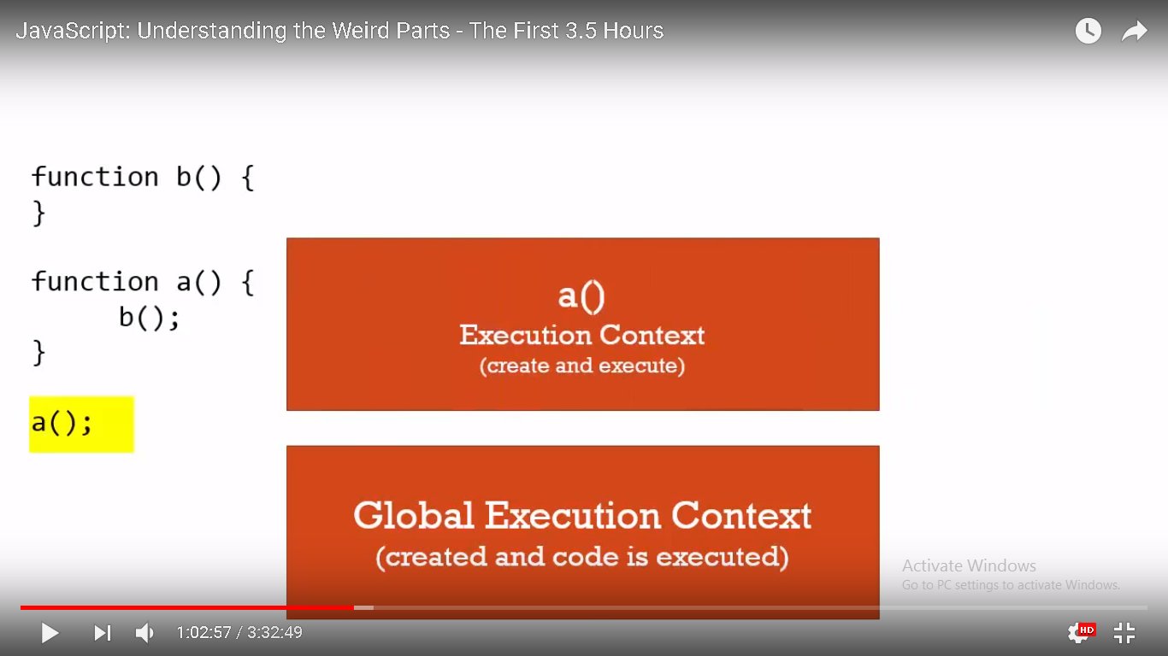

However if i have another function invocation, it will stop at that line of code and create another execution context and run that code.

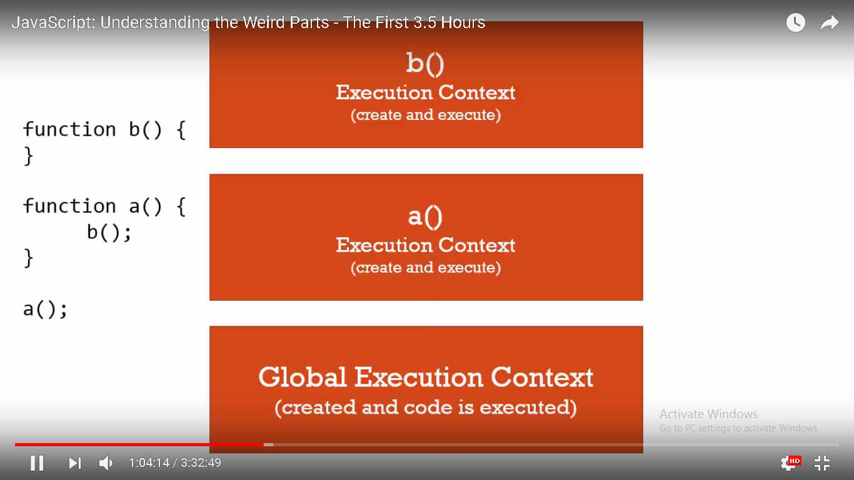

now in case of function b(), there is no code to run but this is how function invocation happens in javascript.

Every function creates a new Execution Context which runs through the Create Phase and then executes the code line by line within the function.

When b() finishes (because it is at the top of the stack), it will get popped off the stack then a() then back down the global.

Now this doesn't matter the order lexically nor does the rest of the code that happens to be surrounding those function calls. for example let's suppose we put function a() above function b() and we have some codes surrounding these function calls. that doesn't matter because even though lexically a() is above b(), both of these functions are already in memory during the create phase of the initial global execution context.

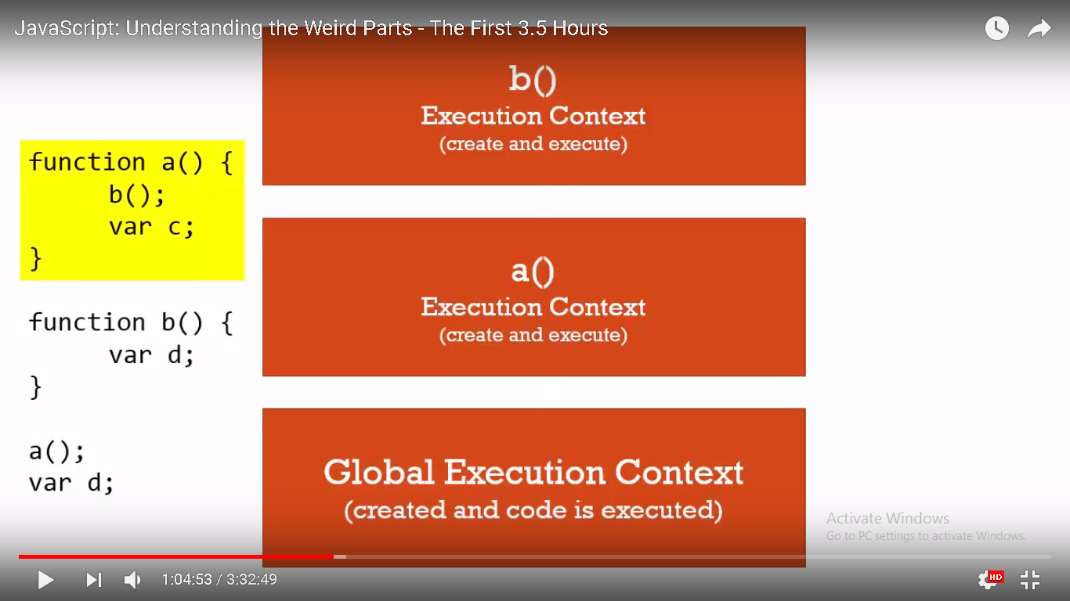

Every time a function is invoked, even if it is invoking itself, a new execution context is created, put on top of the stack and when the function finishes its popped off.

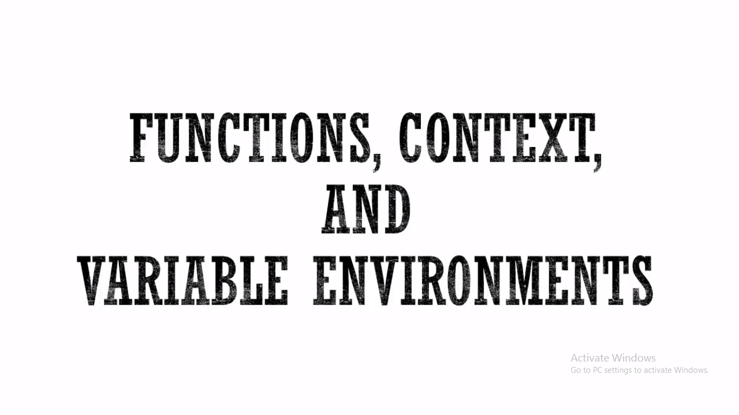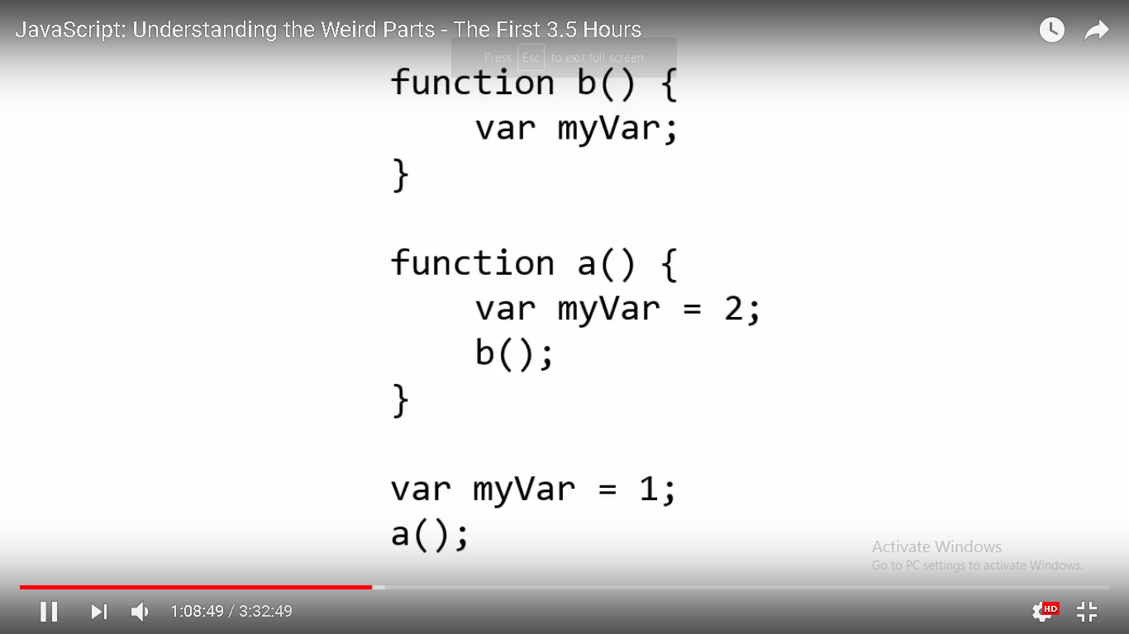

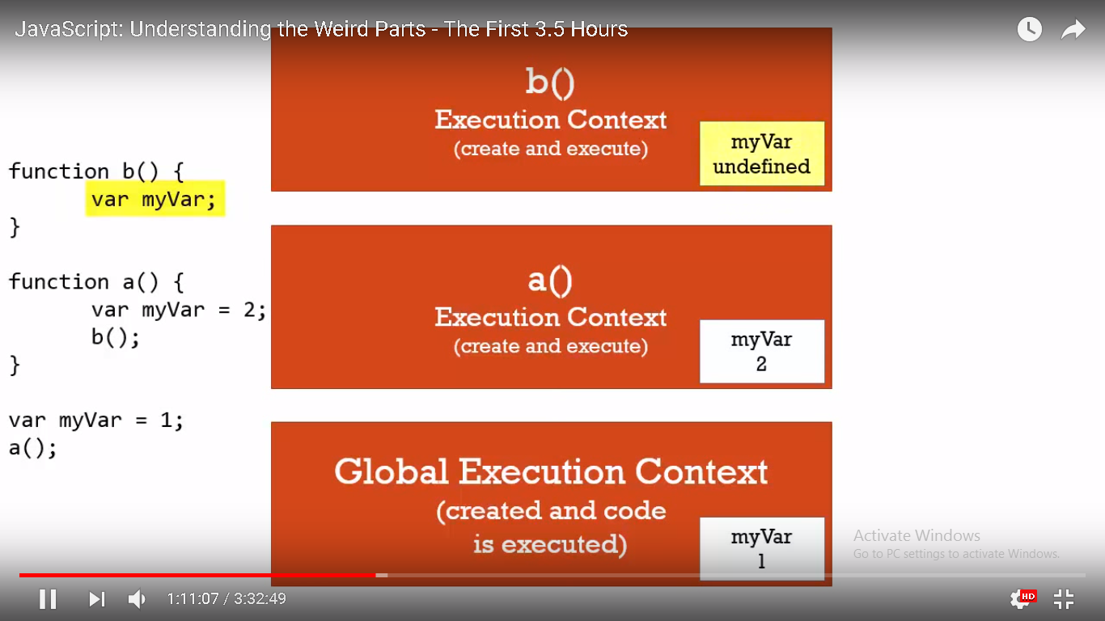

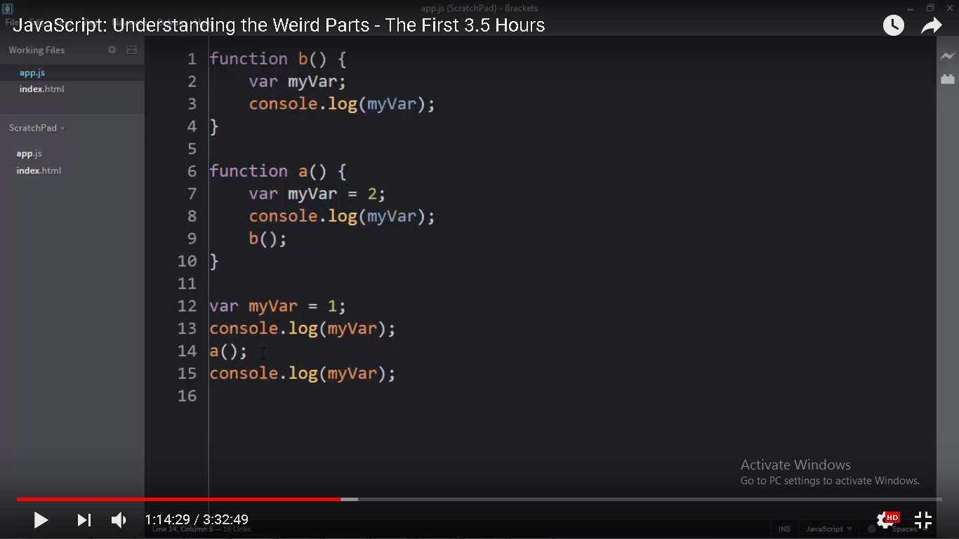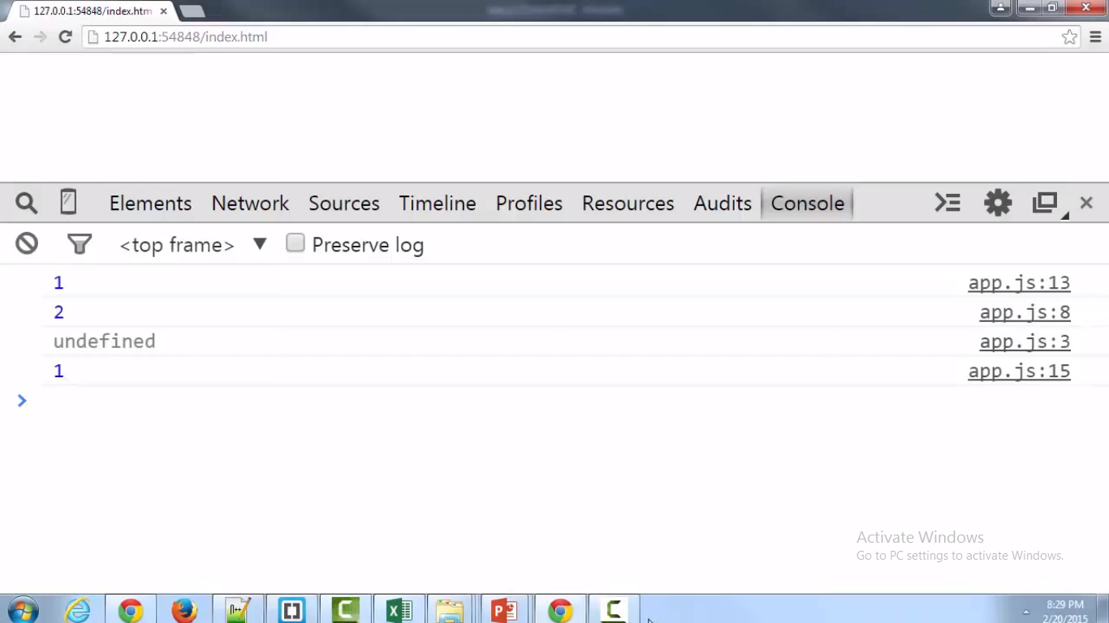

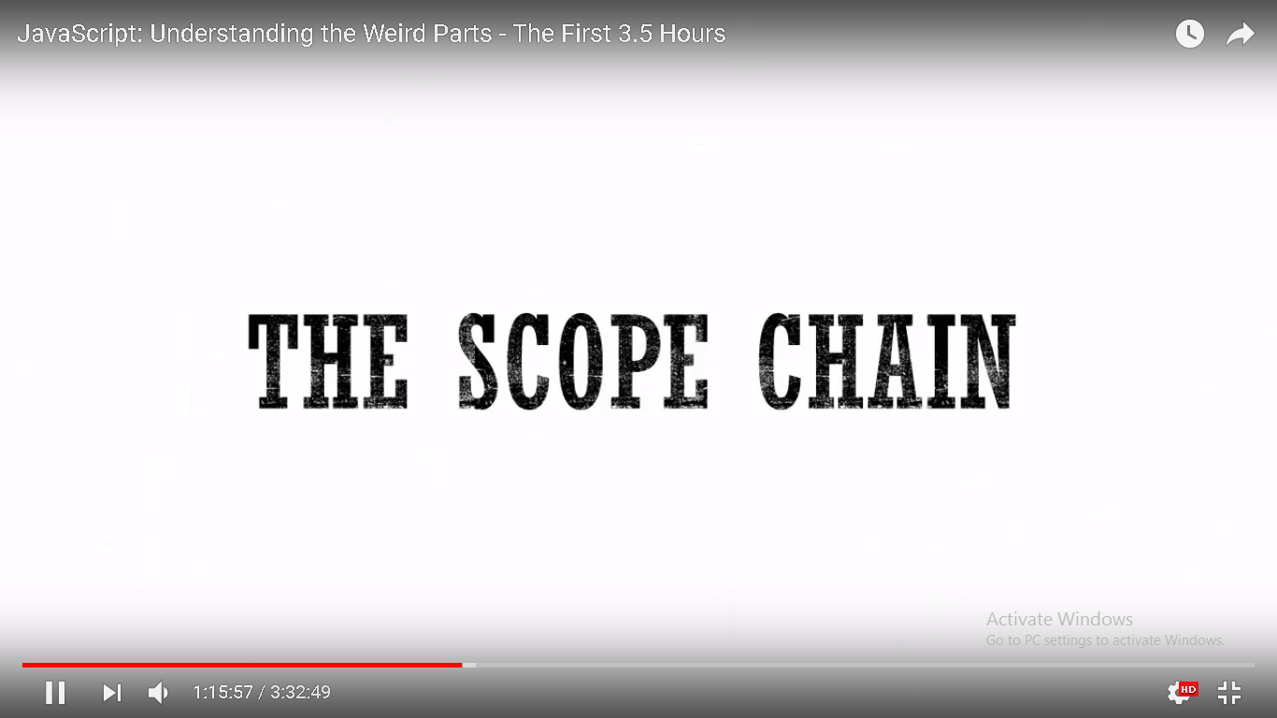

Every execution context has reference to its outer environment. 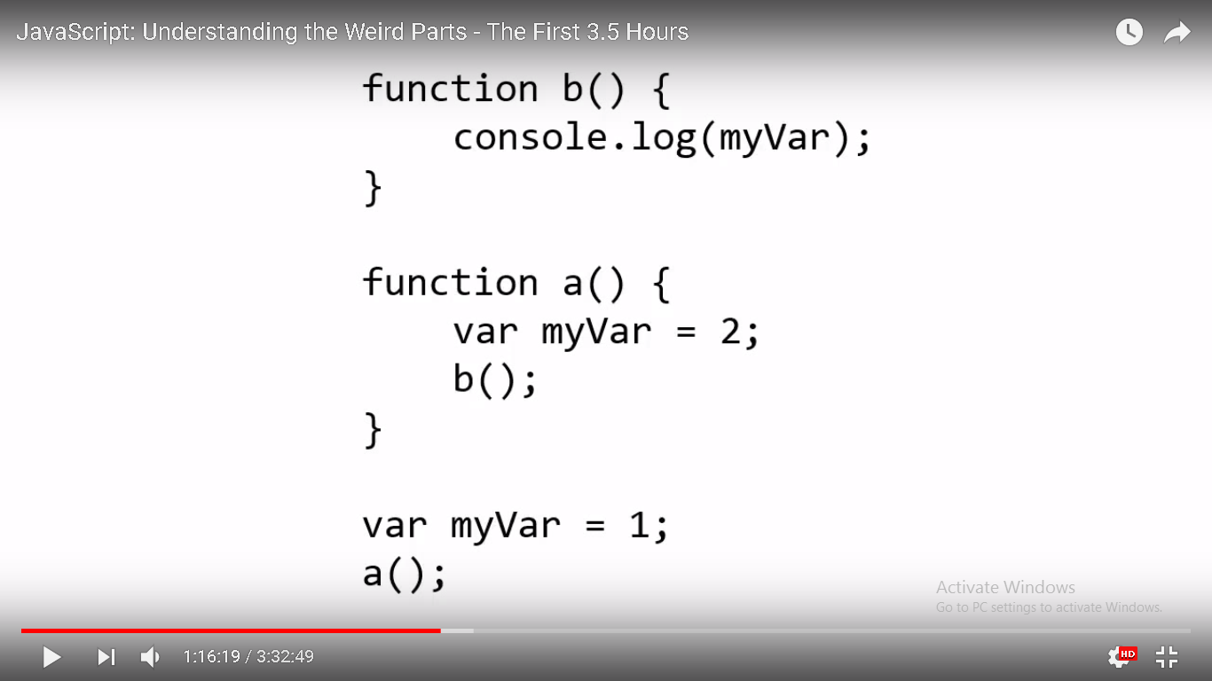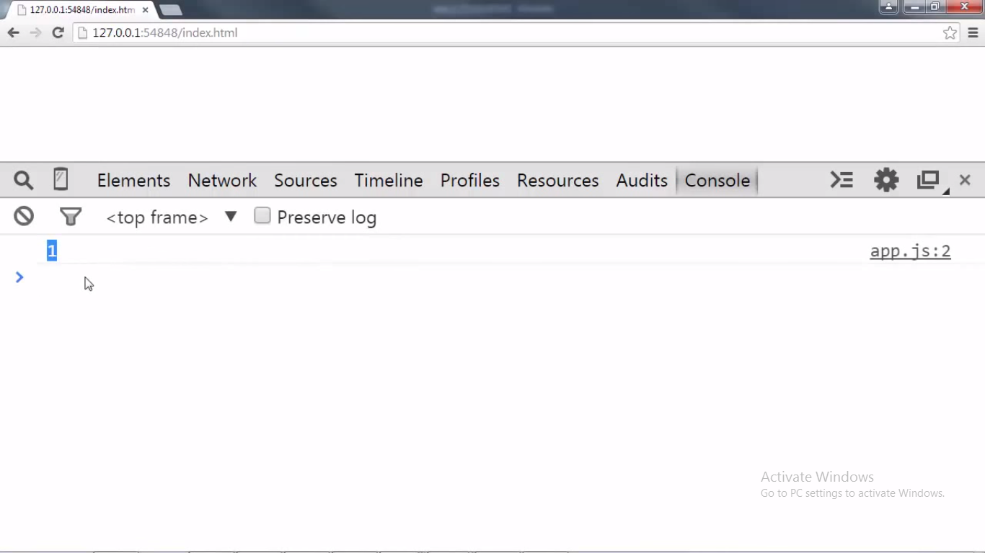

when we do something with a variable, JavaScript does more than just looking in the variable environment of currently executing context. Remember that each execution context has some special things that JavaScript engine created for us like the variable 'this' , the reference to the outer environment.

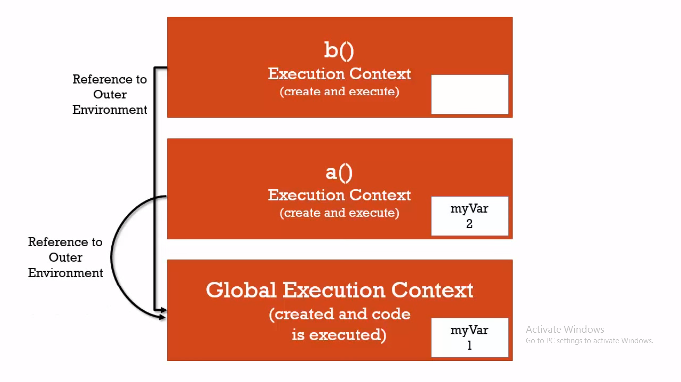

Every execution context has a reference to its outer environment. Now what is its outer environment? In the case of function b(), its outer environment is the Global Execution Context and that's also the case for function a().Even though a() is directly below b() in the execution Stack , as far as what code is going to run, that little outer environment reference that each execution context gets doesn't necessarily have to be the execution context directly below it in the execution stack. Instead, it's something we already talked about. what kind of outer environment are we referring to, that is Lexical environment. Waiiiiit a minute... Lexical Environment? doesn't it mean where something is written physically in our code is important? that it determines certain things as far as how the JavaScript engine will decide and interpret where things live and where things will live in memory and how they will connect to each other ? that's right. So where does function b() live lexically? It lexically sits on top of the global environment. In other words, it's not inside function a(), it's right there sitting at the same level as the last line var myvar=1; , Now don't get lost about this, we are not changing our minds in that the execution context don't matter. Actually don't regard where something is sitting physically in the code meaning a() could be above b() or b() could be above a() as long as they are at the same level. What's going to happen is the order of execution will determine how(when) they are invoked, how those execution contexts are created. However, Javascript does something special, it cares about the lexical environment when it comes to the outer reference that every execution context gets. when we ask for or do something with a variable while running a line of code inside any particular execution context and if it can't find the variable it will look at the outer reference somewhere down below it in the execution stack and that outer reference where that points is going to depend on where the function sits lexically. function b() sits lexically not inside function a() but at the global level so its outer environment(outer lexical environment) is the global execution context. And same case is for the function a(). In JavaScript , when i ask for myvar inside that b() execution context , it couldn't find it so it went down the execution stack and found in the global execution context which is its immediate outer lexical environment.

In our example below, when i ask for myvar inside that c() execution context , it couldn't find it so it went down the execution stack and found in the b() execution context which is its immediate outer lexical environment. if it couldn't find it in b() execution context which is its immediate outer lexical environment(which is depicted in 2nd example below), it will look in next immediate outer lexical environment which is global execution context. Javascript searches this chain of references to outer environment up to the global to find the variable or other resource its looking for.

function b() {

console.log(myvar);

function c() {

console.log(myvar);

}

var myvar=10;

console.log(myvar);

c();

}

function a() {

var myvar=2;

b();

}

var myvar=1;

a();

Output is :

undefined

10

10

function b() {

console.log(myvar);

function c() {

console.log(myvar);

}

//var myvar=10;

console.log(myvar);

c();

}

function a() {

var myvar=2;

b();

}

var myvar=1;

a();

Output is:

1

1

1

**Scope Chain (https://scotch.io/tutorials/understanding-scope-in-javascript)**

In the creation phase of the execution context, the scope chain is created after the variable object. The scope chain itself contains the variable object. The Scope Chain is used to resolve variables. When asked to resolve a variable, JavaScript always starts at the innermost level of the code nest and keeps jumping back to the parent scope until it finds the variable or any other resource it is looking for. The scope chain can simply be defined as an object containing the variable object of its own execution context and all the other execution contexts of it parents, an object having a bunch of other objects.

